Conceptual Design of a Compact Nuclear Reactor Core

Ramiro Vignolo¹, Eduardo Villarino² and Daniel Hergenreder².

1) Instituto Balseiro, Universidad Nacional de Cuyo, Bariloche, Argentina.
2) INVAP SE, Nuclear Engineering Division, Bariloche, Argentina.

Corresponding author: ramirovignolo@gmail.com

Abstract.

Low power research reactors play a key role in the human resources development for the nuclear industry and in the universities. In this work the design of a compact, low power nuclear reactor is presented. The main characteristics of the reactor are: pool type, cooled by natural circulation and partially reflected by beryllium. The well-known MTR U₃Si₂ fuel type was selected for the compact core. Usually the MTR fuel element is an arrangement of several fuel plates. In this design, each fuel plate is considered as an individual fuel element. The compact core resulted in eighty plate-type fuel elements using an enrichment of 19.7% and arranged in an approximately cylindrical geometry. The reactor core has the flexibility to change the configuration by adding/removing fuel plates, adding/removing in-core Pneumatic Irradiation Facilities or by changing the position of the absorber control plates. The core is reflected by several beryllium blocks that provide locations for irradiation facilities such as Pneumatic Irradiation Facilities and a neutron beam. With the adding of beryllium blocks it is possible to compensate the loss of reactivity excess due to burnup. The nuclear performance of the reactor core was evaluated with the INVAP’s Nuclear Calculation System: CONDOR cell code (together with esin2001 and Helios nuclear data libraries) and CITVAP core calculation code. The thermalhydraulic performance was evaluated using CONVEC calculation code. The main design features and core parameters are presented.

1. Introduction

A compact, low power Research Reactor (RR) possesses a great number of different applications, i.e. NAA (Neutron Activation Analysis), education & training, production of radioisotopes in a laboratory-scale or the implementation of a neutron beam. These different uses make them attractive for countries eager in becoming part of the nuclear industry. For this reason, in addition to the recent impulse from IAEA in topics related to Low Power RRs as well as the requirement of INVAP to enlarge its portfolio in such reactors (the LPRR is the only one RR of this kind, and RP-0 and RA-8 as critical facilities), it was decided to carry out this paper in which the design bases of a compact, low power, pool type, cooled by natural circulation of water, partially reflected by beryllium and made with plate-type fuels nuclear reactor were established.

In order to achieve this goal, the materials as well as the geometry of the core were determined. Since this last one is dependent on the nuclear and thermohydraulic parameters, the design could not be a linear process, but it was an iterative one.

Once the core was defined, several nuclear and thermohydraulic parameters were calculated, obtaining as culminating point a thermohydraulic realimentation (THR).

Nowadays, one reactor of these characteristics is the Miniature Neutron Source Reactor (MNSR) designed by the China Institute of Atomic Energy (CIAE) but inspired in the Canadian Slowpoke. The MNSR is a tank-in-pool type RR with highly enriched fuel (∼90% ²³⁵U dispersed in an Al matrix). The maximum nominal power is about 30 kW, being removed by natural circulation. Its HEU pin-type fuels are concentrically arranged in ten circumferences (∼350 pin-type fuels that contains approximately 1 kg of ²³⁵U) and reflected axially and radially by beryllium.

As can be seen in the case of the MNSR, in order to obtain higher neutron fluxes, RR were originally designed and constructed with HEU fuel elements. Given that fast neutron flux is proportional to the volumetric power density and thermal neutron flux to the power per unit mass of fuel (²³⁵U), this type of fuel allows best performance designs.

In the other hand, due to proliferation issues it is convenient to design this reactor core from scratch whit LEU fuel elements (U₃Si₂).

It remains to mention the most conservative restriction in the design bases: in the most reactive configuration (i.e. fresh, cold and without Xe) the reactivity excess should be less than 1 dollar.

Finally, in order to achieve the neutronics performance characteristics, CONDOR cell code and CITVAP core calculation code were utilized. In the other hand, CONVEC calculation code was used to perform the thermohydraulic characterization.

2. Design.

First of all it is convenient to list the design criteria taken into account as follow.

General Design Criteria:
- The reactor will be a multi-purpose low power open pool reactor. The core will be cooled and moderated with light water and reflected with light water and beryllium.
- The core must be compact and consist in an arrangement of several plate-type fuels.
- The nominal reactor thermal power should be around the 30 kW as well as the neutron flux should be equal or higher as the one present in the MNSR.

Reactivity Design Criteria:
- The reactivity excess of the core should be lower than 1 dollar in order to avoid prompt critical.
- The total power feedback coefficient shall be negative for any operating condition, and all temperature and void coefficients of reactivity associated with the coolant and fuel temperature coefficient will be negative for all operating states and accident conditions unless it is shown that the coefficient has an insignificant effect.
- The shutdown margin should be at least 3000 pcm.
- The core shall be subcritical with a shutdown margin of at least 1000 pcm, with any of the control rods out of the core.

Thermohydraulic Design Criteria:
- The power peaking factor shall be lower than 3.
- The minimum Onset of Nucleate Boiling (ONB) Ratio shall be greater than 3.
- The Onset of Net Vapor Generation (ONVG) Ratio shall be greater than 2.

2.1. Neutronic Design

As a starting point it was determined if four MTR fuel elements from the RA-6 research reactor reflected radially by beryllium, axially by light water and disposed in an arrangement consisting in 2x2 can reach criticality. This has to do with the fact that these four RA-6 MTR fuel elements have a similar ²³⁵U mass that the one present in the MNSR converted to LEU. The corresponding models were performed in CONDOR (see FIG.1.) and CITVAP, where it was found that criticality was achievable with a beryllium thickness of 13 cm (as a rectangular reflector).

Once this satisfactory outcome was obtained, it was decided to remove the fuel elements frames and consider each plate as a standalone fuel (see FIG.2.). This not only allowed to assemble a core with a more convenient fuel distribution, but it also provided a great amount of versatility (as it occurs in the LPRR whit its pin-type fuel elements). It was found the layout presented in the FIG.3. after studying which number of fuel elements allowed an approximately cylindrical geometry (98 fuel plates). In order to do this, several considerations were taken into account (contemplate that the ²³⁵U mass should be preserved):
- First of all, a great number of plates is limited by their production cost.
- If the active length or height of the plate is varies, two limitations appear. On one side, a small length has a thermohydraulic limit (in terms of natural circulation). On the other side, a great length is limited by stability issues (it becomes a slender plate).
- If the thickness of the meat is varied, two manufacturability limitations appear. Also, a great thickness is limited by thermohydraulic issues because this affects both the fuel temperature and the exigency of each plate (considering constant power and ²³⁵U mass).

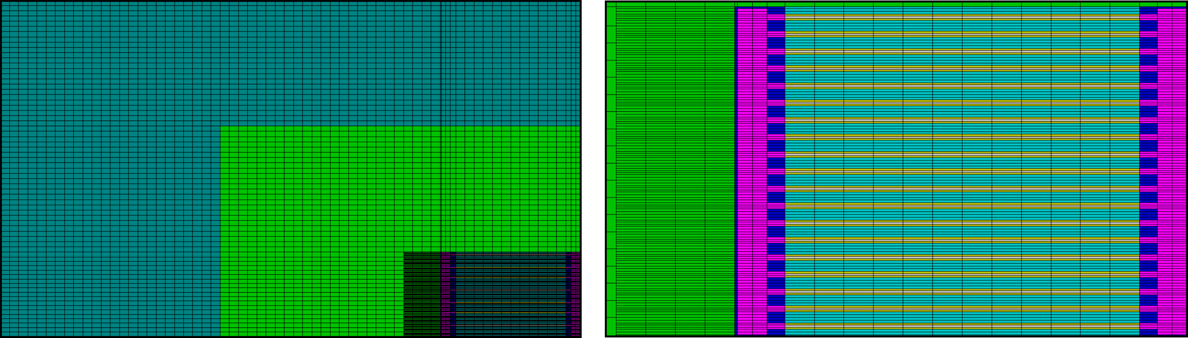
FIG.1. A quarter of a 2x2 core modeled in CONDOR. The left figure shows the core reflected by beryllium (green) and water (blue). The right figure corresponds to a zoom of the fuel element.

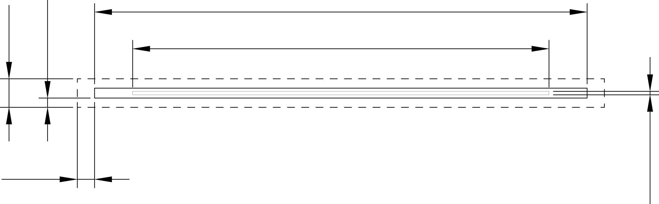
FIG.2. Fuel element. The dashed line delimitates the elementary cell of the core. Dimensions are intentionally avoided.


FIG.3. First reactor core: the solid line around the core shows the beginning of the beryllium. The dashed line indicates the circle which circumscribes the core. Dimensions are intentionally avoided.

Later, this core was calculated using a CONDOR (see FIG.4., note that a quarter of the core was modeled) cell core model in order to obtain the macroscopic cross sections to feed the core calculation code CITVAP.

The FIG.5. shows the moderation curve, i.e. the reactivity (ρ) vs. pitch (varies accordingly to the thickness of the water channel) for the core presented before. It can be seen that the operating point is both strongly sub moderated and way beyond the wanted reactivity excess. These two inconvenient could not be overcome just modifying the moderation ratio, given that the sub moderation requires increasing the pitch while the decrease of the reactivity excess needs the opposite.

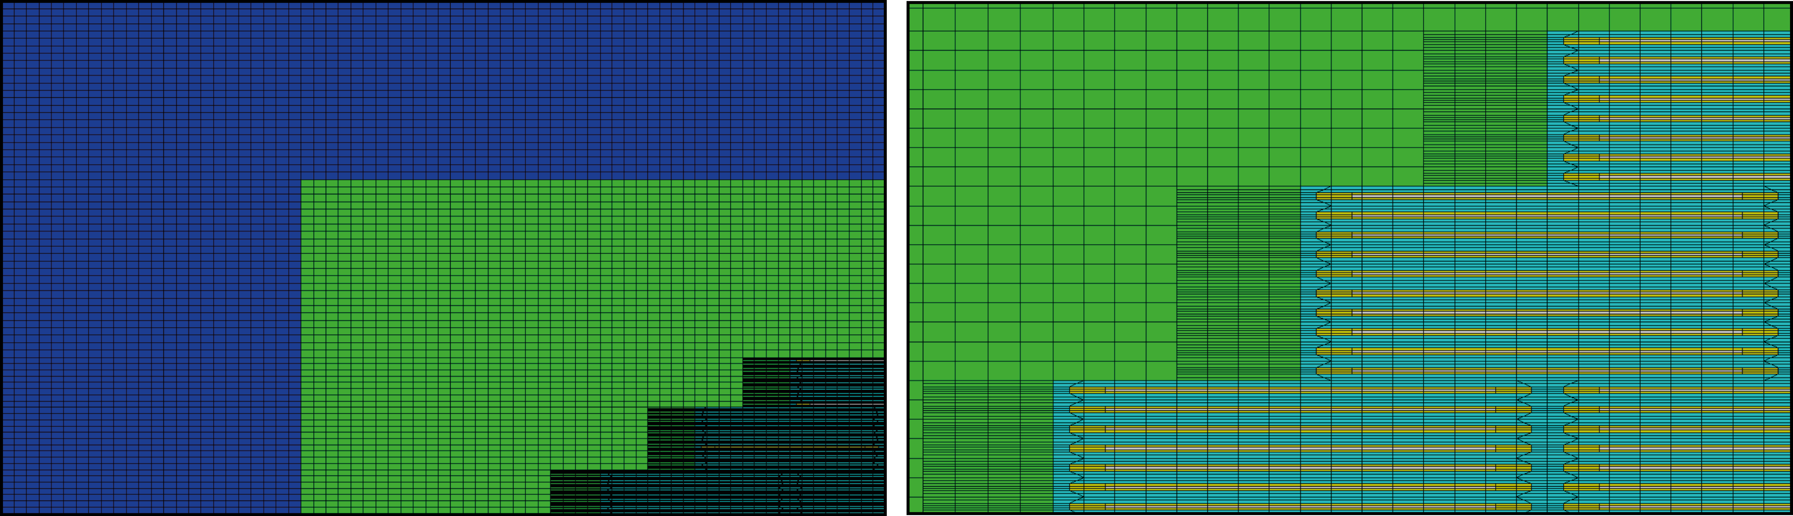
FIG.4. Quarter of the core modeled in CONDOR. The left figure shows the core reflected by beryllium (green) and water (blue). The right figure corresponds to a zoom of the fuel elements.
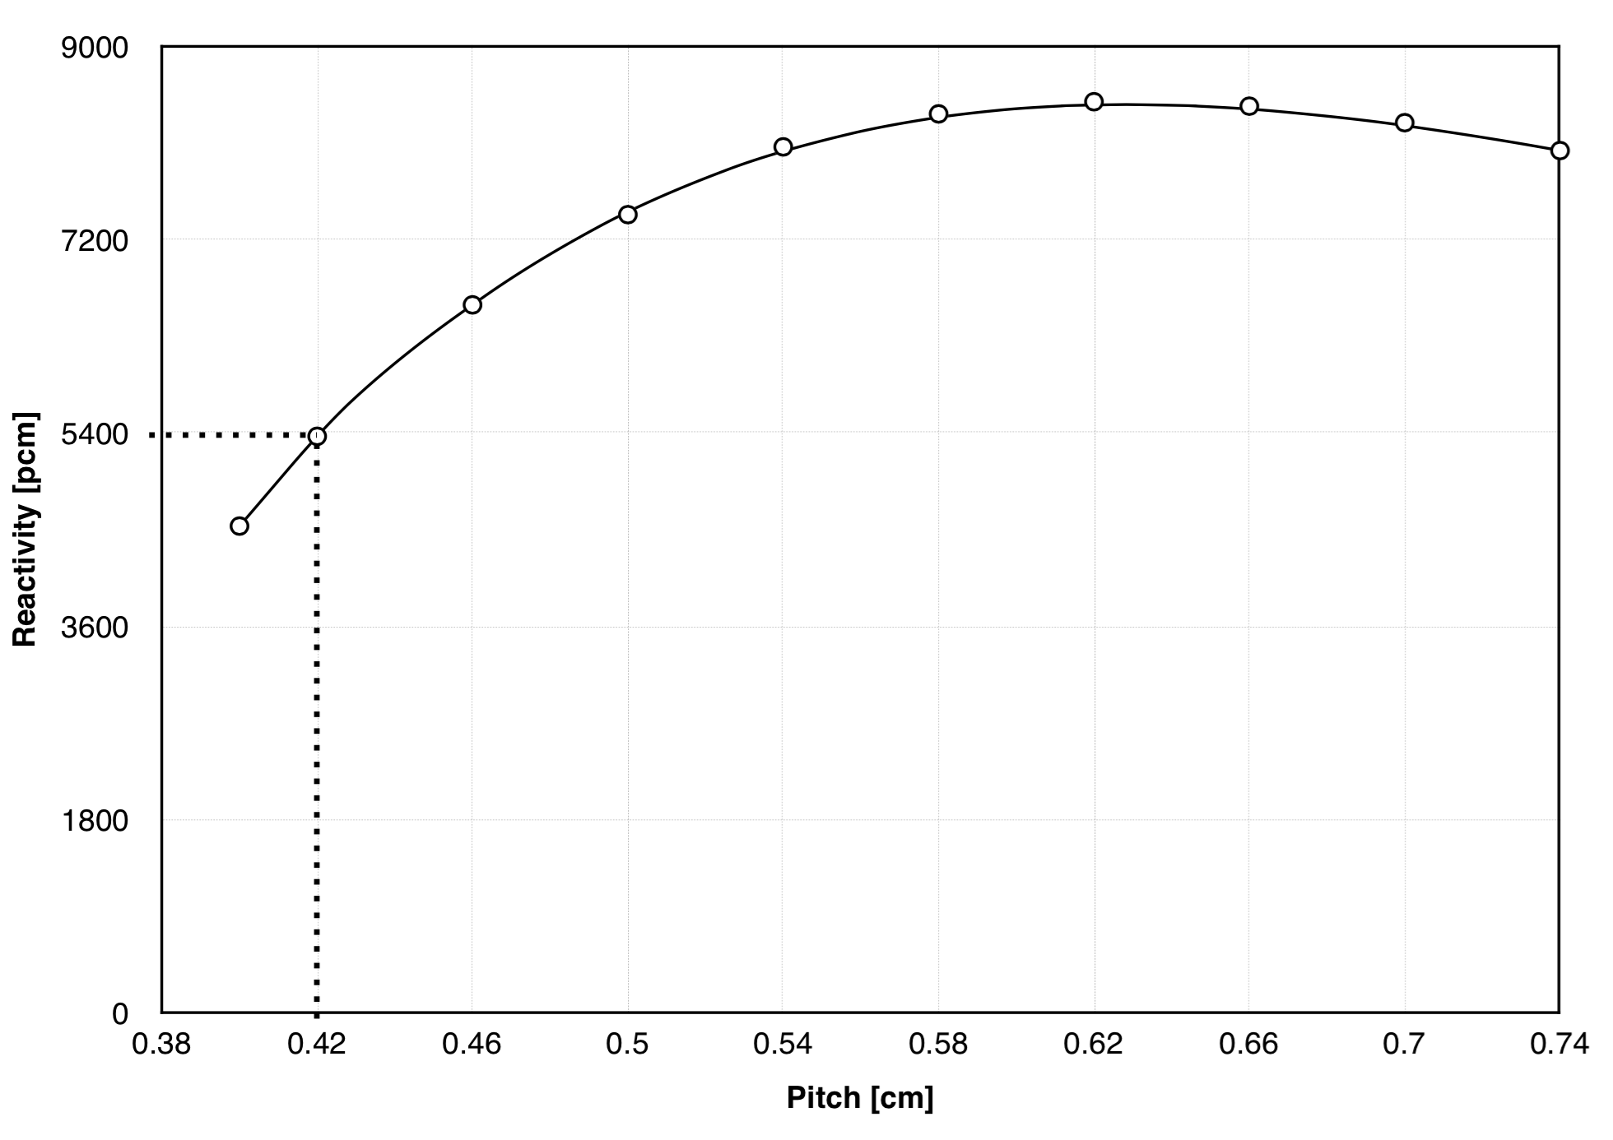
FIG.5. Moderation curve for the reactor of 98 fuel elements. The dotted line represents the operating point.

Before proceeding it is worth emphasizing some items considered when using the moderation curve (ρ vs. moderation ratio r):
- There is a minimum moderation ratio r_{min} for which the thickness of the water channel is so small that the heat removal would be affected (the boundary layers meet). In addition, this operating point could be a strongly sub moderated (this involves poorly use of the fuel).
- There is a maximum moderation ratio r_{max} for which the void coefficient is equal to zero. As a safety margin, r_{max} is taken such that ρ_{max} − ρ(r_{max}) ∼ 1000 pcm.

Let’s suppose that the design process was a linear one. The FIG.6. presents a design scheme:
- The first point lies over the dots moderation curve and corresponds to the case showed in the FIG.3.
- The second point lies over the triangles moderation curve and corresponds to a core similar to the previous, except that in this case the thickness of the cladding was increased. The reason of such modification lies in the neediness of stiffer plates, so they can be manipulated comfortably in the pool tank.
- The third point lies over the triangles moderation curve and corresponds to a less sub moderated operating point.
- In principle there are three ways to decrease the reactivity excess: modify the enrichment, the beryllium thickness or change the geometry (vary the number and distribution of the plates). The first choice was discarded because it doesn’t make any sense. The second choice was also discarded because it has to do with the fact that reducing the thickness of beryllium would lead to bigger cores that the ones that could be done, diminishing the neutron flux (in the other hand, if the core volume and power are maintained, the compensation of the reactivity with beryllium due to burnup would lead to a greater reactor life, so this is a must study). Finally, the decision made in this case was the change of the core arrangement, obtaining the fourth point over the squares moderation curve.
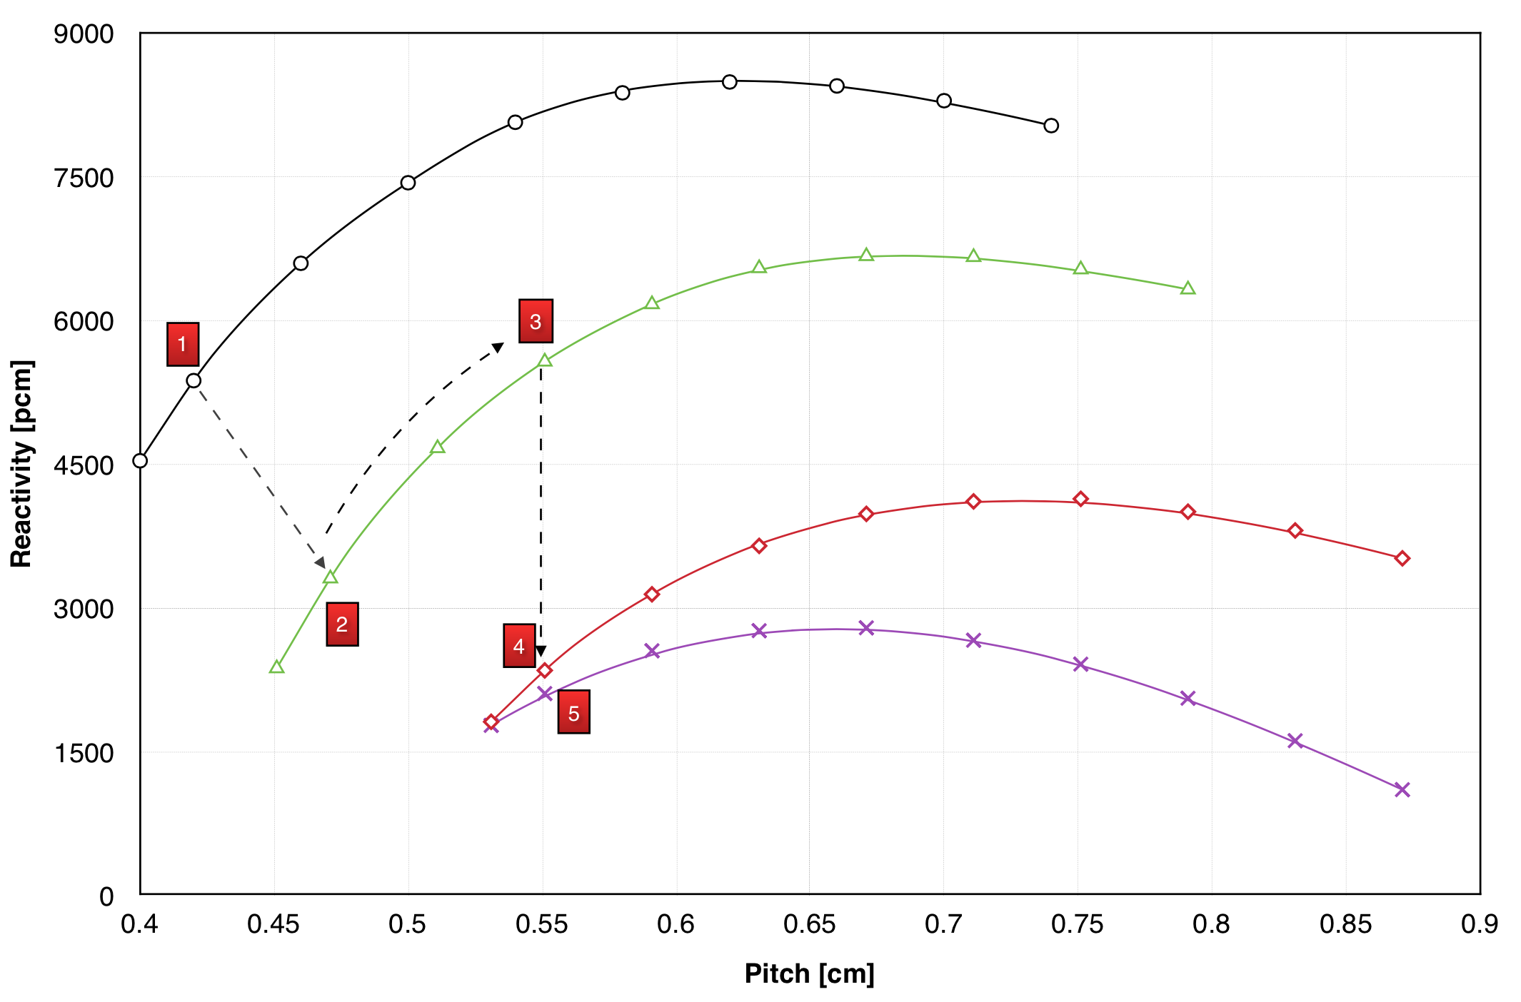
FIG. 6. Design scheme: moderation curves for the different reactors.

- After the core’s change, a flux trap and the position for control rods were added (see FIG.7.), resulting in the fifth point over the crosses moderation curve. It should be clarified that the flux trap is formed by the position of four fuel elements, so it might move to another place or whatever the operator desire. This core has 80 plate-type fuels, 2 in core control rods positions, 48 cm of active length, 1108 g of ²³⁵U and 2100 pcm reactivity excess (greater than β because things that would diminish the reactivity excess weren’t considered at this point).

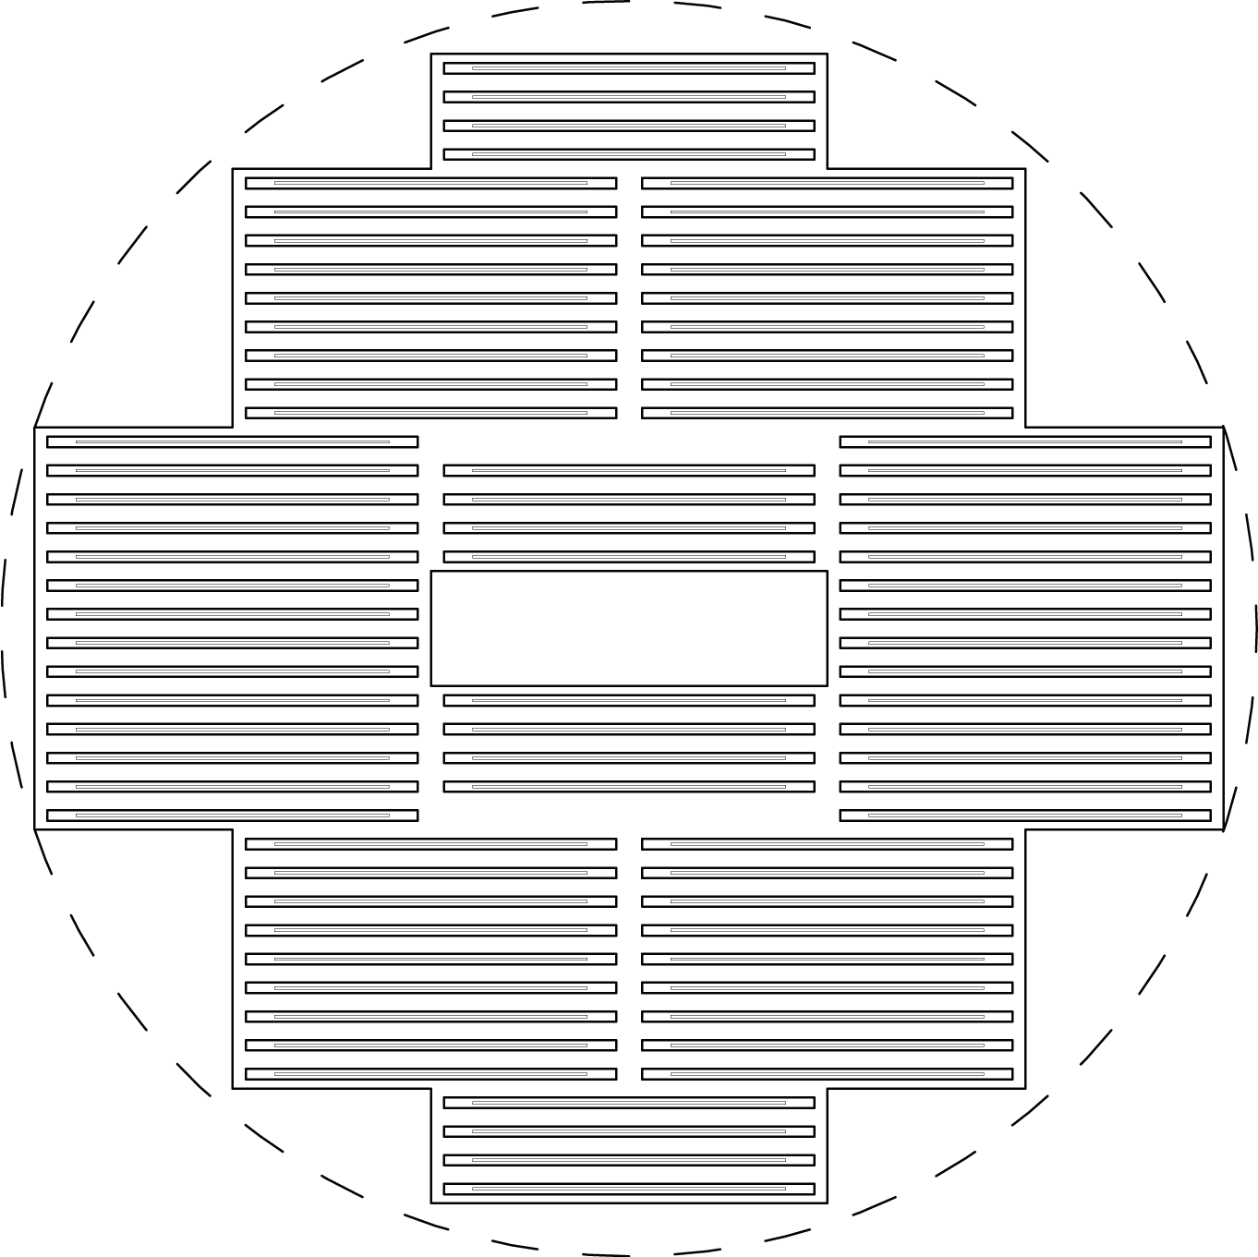
FIG.7. Final reactor core: the solid line around the core shows the beginning of the beryllium. The dashed line indicates the circle which circumscribes the core. The flux trap is also represented. Dimensions are intentionally avoided.
2.2. Evaluation and Analysis of the Core

Next, a series of studies performed in parallel with the neutronic design are presented.

Analysis of the fuel elements arrangement.

The spatial distribution of the fuel elements was not left to chance. In that sense, a detailed analysis was carried out in which the number, the height and the arrangement of the plates were modified in order to leave the ²³⁵U mass constant. The result is showed in the FIG.8. Note that these curves are actually discrete (this will be clarified shortly). The crosses curve consists in the reactivity that a core would have if it varies the number of three plates row by adding/removing them. The triangles curve consists in the reactivity that a core would have if it varies the number of two plates row by adding/removing them. Finally, the squares curve consists in the reactivity that a core would have if it varies the number of one plate row by adding/removing them. The point where the curves intersect corresponds to the designed reactor (80 plates and 2100 pcm reactivity excess). Thus, it is shown that the reactor would have a greater reactivity excess if we only modify the number of one plate row (four more plates, i.e. four new one plate rows in the core, implying a smaller height). This was left unchanged because the owner could add plates in these places during the reactor’s life. It was also seen that the reactivity worth of each plate is different.

Flux Trap.

The implementation of a flux trap would allow the use of three Pneumatic Irradiation Facilities. In this case, at a power of 30 kW, the thermal neutron flux is about 2.1 x 10¹² n/cm²·s in the flux trap, while in the beryllium reaches 1.4 x 10¹² n/cm²·s. It will be shown that the reactor power could be increased and thus the fluxes.

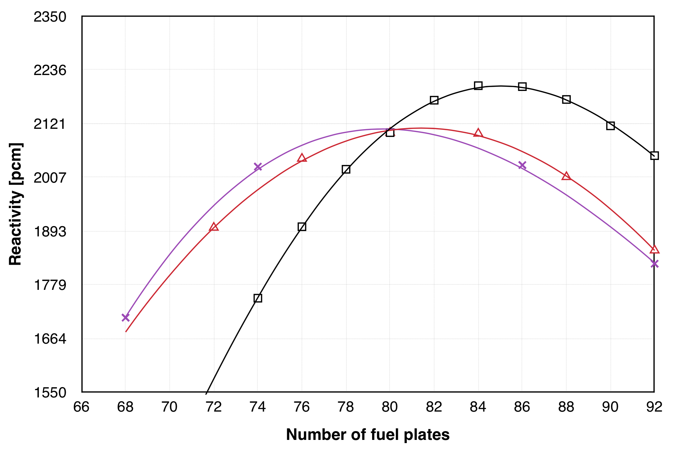
FIG.8. Reactivity vs. number of plates leaving the ²³⁵U mass constant.

In-core and Regulating (out-core) Control Rods.

Hafnium was selected as material in both the in and out-core control rods (the same measures as those of a fuel element were taken).
In-core control rods worth around 7000 pcm meanwhile out-core control rods 2200 pcm (located at the point of the thermal peak in the beryllium). These regulating control rods could be relocated in order to decrease their weight. In the other hand, in the case of the in-core control rods, hafnium could be changed for another material if desired.

Reactivity Feedback Coefficients.

Different reactivity coefficients were obtained for BOC and during the reactor’s operation. They are presented in the Table I. It should be clarified that the coolant (and moderator) temperature coefficient α_{Tcool} considers the density variation.

Xenon.

Since there is a very restrictive condition on the reactivity excess, a detailed study concerning how much reactivity the xenon takes off must be carried out. This is because if the xenon is taken as if it was in equilibrium might be a very conservative consideration. In order to avoid this consideration, an operation scheme for the reactor was proposed: 8 hours per day, 5 days a week. It was consider an average thermal flux to solve the pertinent differential equations (iodine and xenon concentrations) and the result is presented in the FIG.9. Now it can be seen that the xenon concentration never reaches the equilibrium value, if not only 40% of it (the analysis does not change for any other power of interest in terms of percentage). At 30 kW, ρ_{xe} = − 0.4·300 pcm = −120 pcm.

Burnup.

Let’s suppose that the reactor has a reactivity excess of 800 pcm (assume that the rest was consumed by Pneumatic Irradiation Facilities, frames, water channels for cooling the beryllium, etc.). The cold-hot jump would consume around 320 pcm and the xenon at most 120 pcm. This leaves the reactor with 350 pcm for burnup. The reactivity loss will be compensated with the addition of beryllium blocks.
The FIG.10. shows two different ways in which the core could be burned with the core calculation code. The triangle curve begins with the most reactive condition of the core (i.e. infinitely reflected with beryllium). While in the dots curve the reactivity loss is compensated by adding beryllium blocks when appropriate (and without exceeding 350 pcm). Both figures reported similar reactor life value: 1860 FPD (Full Power Days) that, in the proposed operating scheme, account for more than 20 years.

TABLE I: Reactivity Feedback Coefficients.
Fuel Temperature Coef. α_{Tfuel} [pcm/K] | −1.6
Coolant Temperature Coef. α_{Tcool} [pcm/K] | −16.8
Void Coef. α_{v} [pcm/%] | −177.8
Power Feedback Coef. α_{p} [pcm/kW] | −1

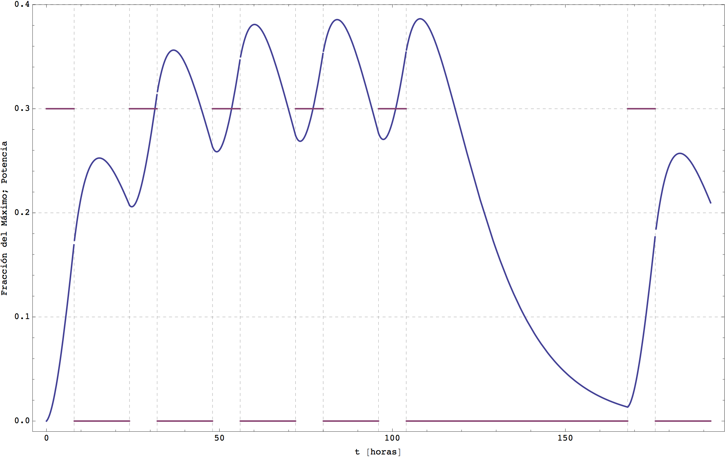
FIG.9. Dimensionless xenon concentration (percentage of the equilibrium value). Operating scheme: 8 hours per day, 5 days a week. The first week is shown in the graphic. In the other hand, the horizontal lines show the operation/shutdown of the reactor.

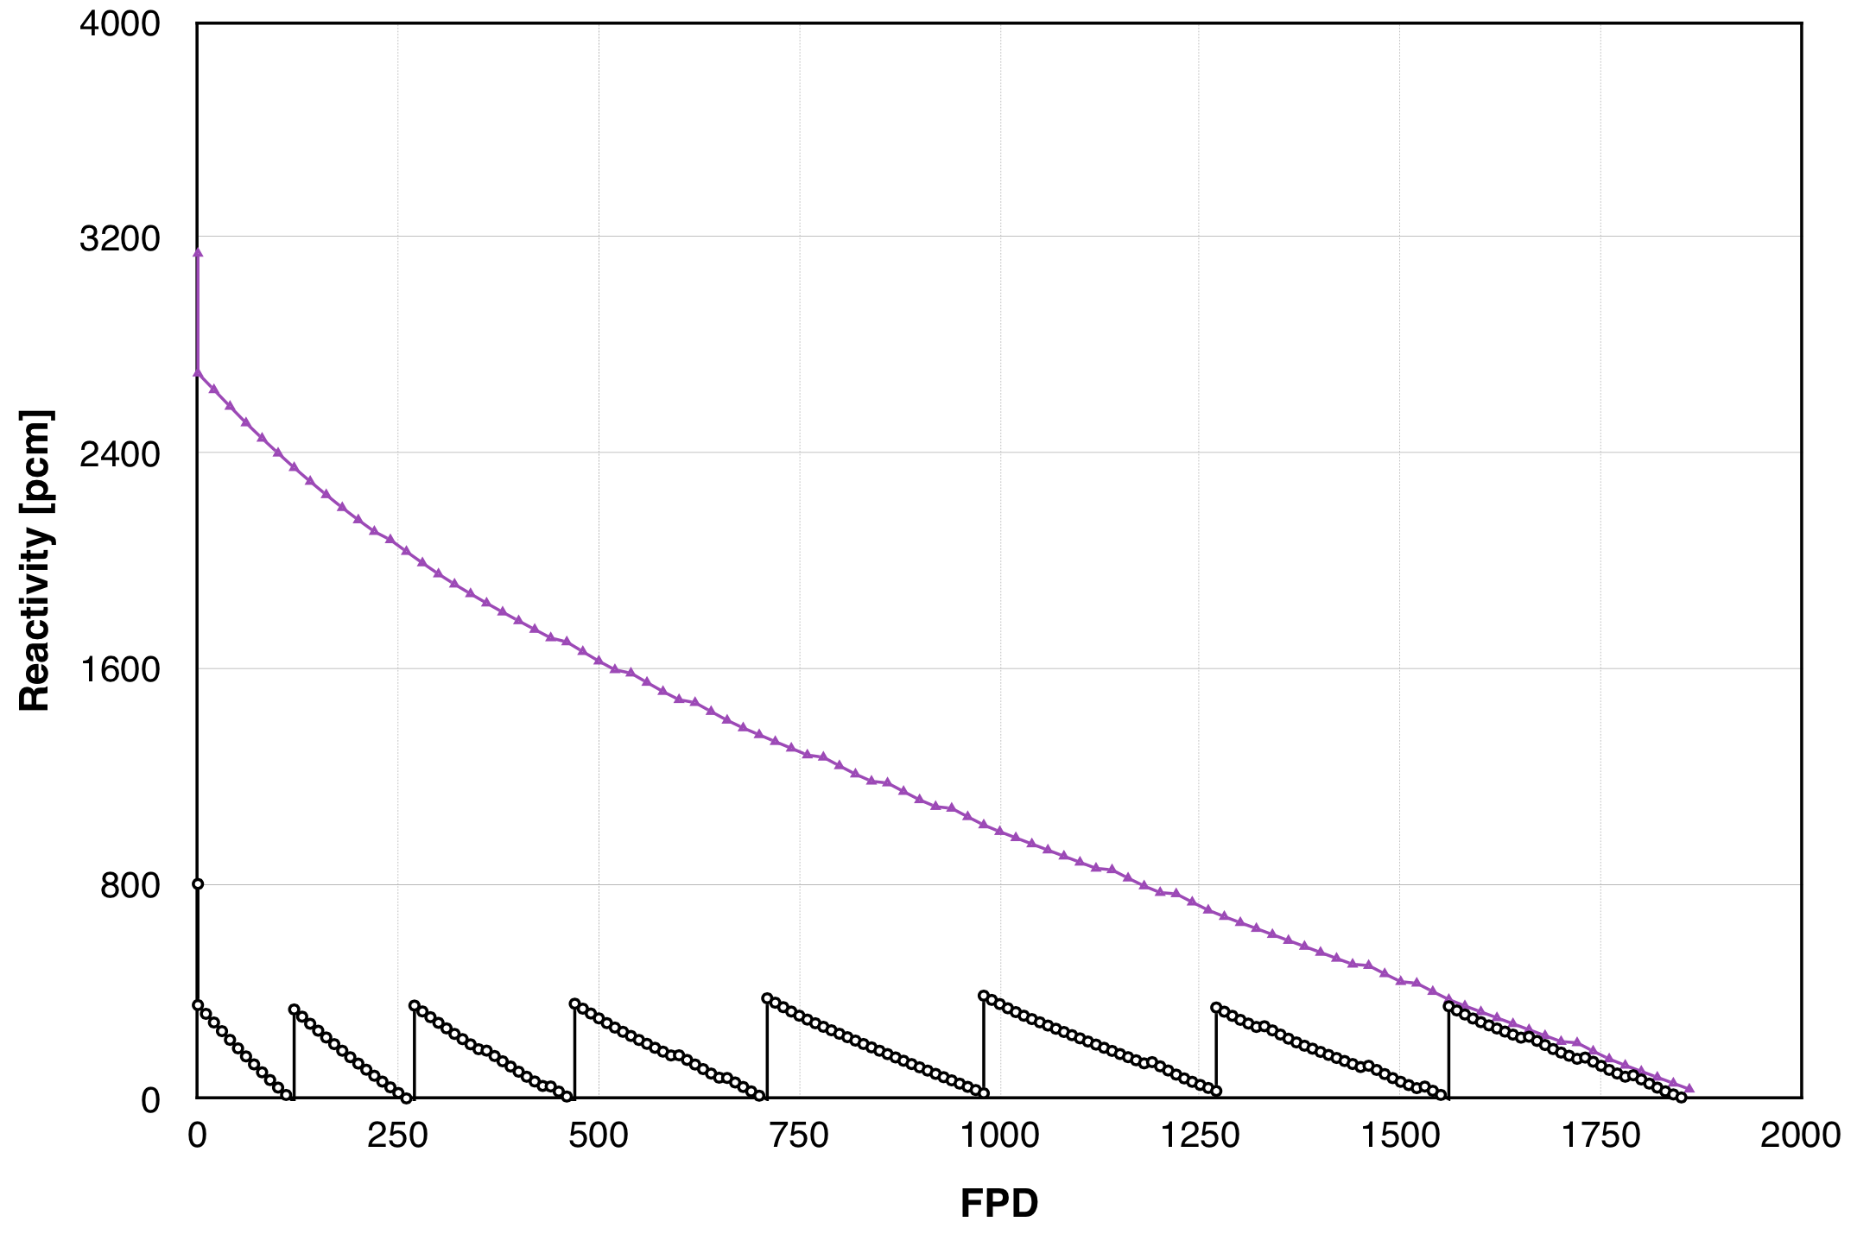
FIG.10. Two different ways to estimate the reactor life.

2.3. Thermohydraulic Design

As it was mentioned before, CONVEC calculation code was used for the evaluation of the core’s thermohydraulic performance. Nevertheless, a theoretical model was also proposed so both results could be compared. This theoretical model takes into account the following items:

- The linear power density comes from the surrounding fuel elements (see FIG.11.).
- The coolant density only varies in the gravitational term if the moment equation.
- Steady state.
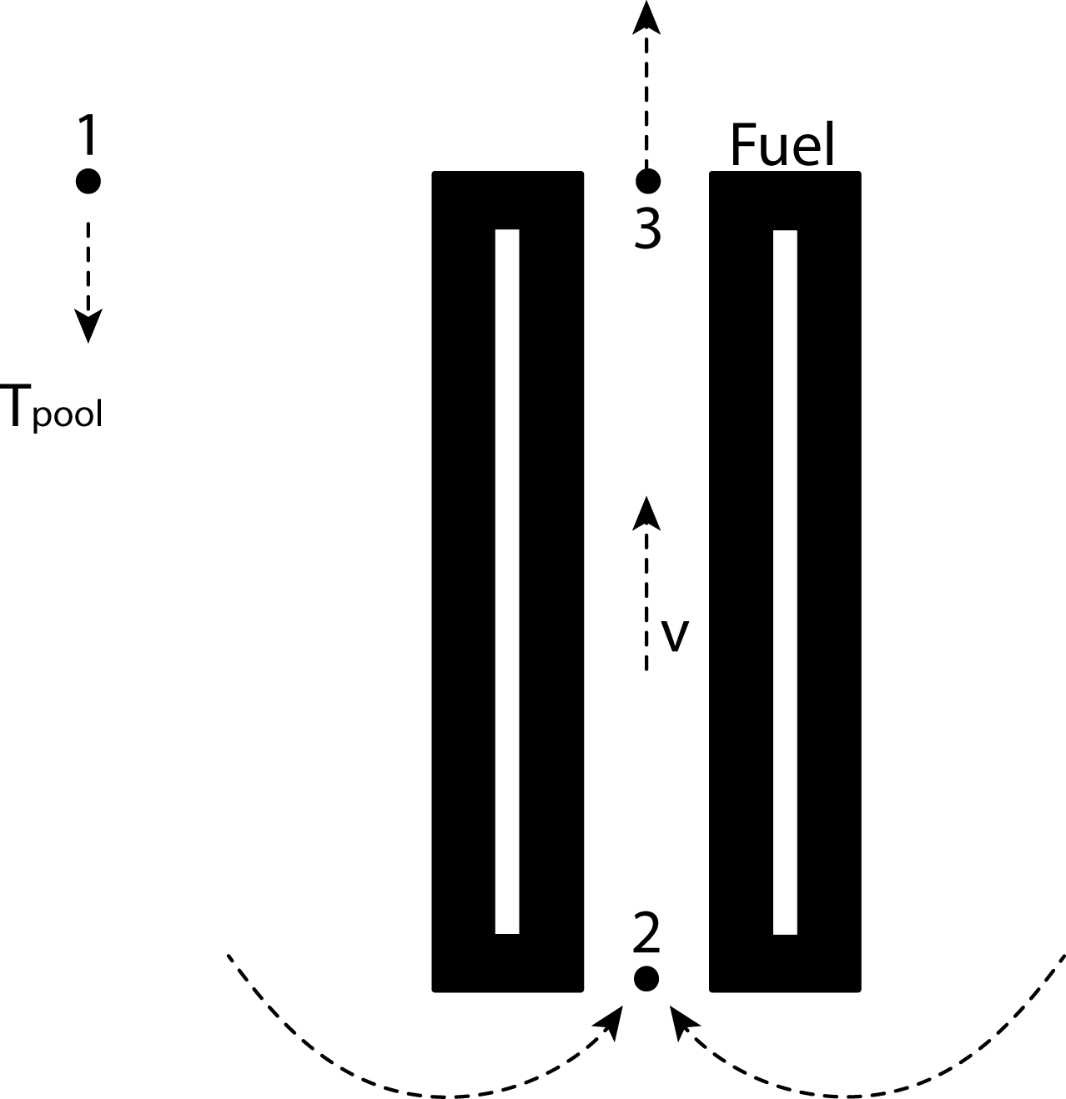
FIG.11. Representation of the problem.

The resulting equations for the conservation of momentum and energy are coupled, so the resolution must be iterative. It is important to note that several parameters are also temperature dependent (Reynolds number, contraction and expansion factors, etc).

The peaking factor determined for this reactor was 1.88. Contemplating uncertainties and control rods position, the peaking factor was increased to 2.5. The linear power density fed to both calculation codes and results are shown in FIG.12. It can be seen that the theoretical model gives a conservative result.

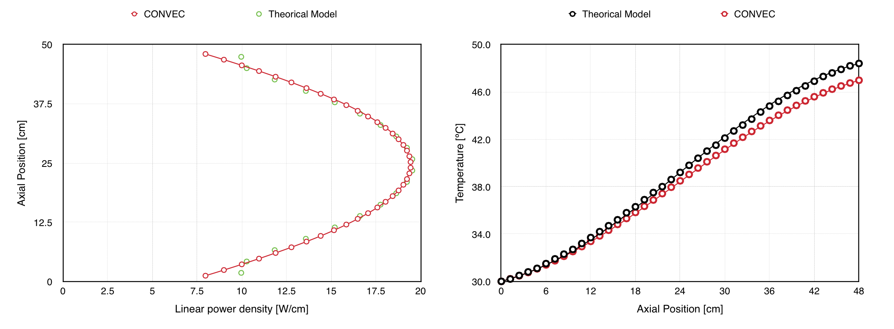
FIG.12. Linear power density vs. axial position fed to CONVEC and to the theoretical model. Coolant temperature vs. axial position.

Finally, a THR could be easily performed because CITVAP can be coupled with CONVEC, obtaining α_{p} = −1 pcm / kW. In the other hand, the minimum ONB corresponded to 3.9 and the ONVG ratio to 4.9.

3. Conclusions

It was shown that a compact research reactor could be harmoniously done with fuel-plate type fuels. All requirements were met but some of them could be improved. In this sense, the design bases have been clearly established.

In particular, a detailed study should be carried out by modifying the thickness of the beryllium instead of the core geometry, in order to see which decision is more convenient.

4. References

- IAEA. Research Reactors Data Base, 2014.
- Cheverton, R. D. “Reactor Design and Feasibility Problem: High Flux Research Reactor”. OAK Ridge School of Reactor Technology, 1956.
- Villarino, E., Doval, A. “Invap’s Research Reactor Designs”. INVAP S.E., September 2010.
- Matos, J. “Best practice analyses supporting conversion of research reactors from highly enriched uranium fuel to low enriched uranium fuel – the case of miniature neutron source reactors”, June 2012. Yet unpublished.
- Omar, H. “Experimental and operational validation of burn-up calculations for the Syrian MNSR”. Atomic Energy Commission, Nuclear Engineering Department, 2010.
- U.S. Department of Energy. “Reduced Enrichment for Research and Test Reactors Program”, 2014.
- Matos, J., Bretscher, M. M. “Neutronic performance of high-density LEU fuels in water-moderated and water-reflected research reactors”. Argonne National Laboratory, 1996.
- Mochi, I. “Invap’s Nuclear Calculation System”. INVAP S.E., August 2010.
- Lamarsh, J. R. “Introduction to Nuclear Reactor Theory”. Addison-Wesley Publishing Company INC, 1966.
- Bazzana, S., Márquez, I. “RA-6 Reactor: Water reflected, water moderated U(19.77)₃Si₂-Al fuel plates”. CNEA, 2012.
- Bazzana, S. “Desarrollo, análisis y evaluación de experimentos neutrónicos en el RA-6”. Proyecto Fin de Carrera, Instituto Balseiro, Marzo 2012.
- Duderstadt, J. J. “Nuclear Reactor Analysis”. John Wiley and Sons INC, 1942.
- ldel chick, I. E. “Handbook of Hydraulic Resistance”. See CONVEC manual.
- White, F. “Fluid Mechanics”. McGraw-Hill Series in Mechanical Engineering, 2000.

