Expansion of the Cold Neutron Facilities and Reactor
Upgrades at the NIST Center for Neutron Research

R. E. Williams

NIST Center for Neutron Research, 100 Bureau Drive, Mail Stop 6101
Gaithersburg, MD 20899 USA

Corresponding author: robert.williams@nist.gov

Abstract. The NBSR is a 20 MW research reactor operated by the NIST Center for Neutron Research (NCNR) as a neutron source providing beams of thermal and cold neutrons for research in materials science, fundamental physics and nuclear chemistry. A major expansion of the cold neutron facilities of the NCNR was launched between 2007 and 2012 under the America Competes Act, a government wide initiative to double the nation’s capabilities in the physical sciences. The cold neutron guide hall was enlarged to accommodate 5 new guides and a technical support building was erected for the expanded support staff and equipment. A 13-month shutdown was needed to install the new guides and to install a second cold neutron source, the 0.5 litre liquid hydrogen source in the thermal beam port, BT-9. That shutdown was completed in April 2012. In addition to the expansion, a number of projects were completed to upgrade and modernize many of the auxiliary systems needed for continued operation for the duration of the facility license, which expires in 2029, and, hopefully beyond that. These projects included:

- A new secondary cooling pump building and new pumps.
- A major modification to the thermal shield cooling system for vacuum driven flow.
- The above mentioned second liquid hydrogen cold source for the MACS spectrometer.
- Five neutron guides to the new guide hall.
- A compressor building for a new refrigerator needed for a future liquid deuterium cold source.
- An upgrade of the fuel storage pool including a new pool liner and high-density storage containers.
- A switch yard providing additional AC power capacity.

As a result of the expansion project, 5 new or upgraded cold neutron scattering instruments were made available to facility users in 2013, with a few more scheduled for completion in the next two years. Future projects include the installation of a liquid deuterium cold source and a gradual, phased transition toward a digital reactor control console.

1. Introduction

The last few years have been a period of remarkable growth for the NCNR. The number of guest researchers and experiments had almost reached saturation a decade ago as all available thermal neutron beam and cold neutron guide positions were occupied. With the demand for beam time growing, NCNR sought support for a new cold neutron guide hall. As a result, when the US government launched a program to double its funding for the physical sciences, the expansion of the NCNR was included explicitly in the America Competes Act. A five year program was initiated with construction of a new guide hall and a two story technical support building, and funding for five cold neutron guides and five new scattering instruments. The initial expansion plan called for installation of the new guides in BT-7 (see Figures 1 and 2) and a guide hall west of the reactor building, perpendicular to the existing guide hall. Later it was decided the new guides would emerge from the CTW beam port and the new guide hall would be an addition to the existing hall. This arrangement forced major changes to the reactor secondary cooling system because the guides would displace secondary piping and instrumentation in the old pump house. Fortunately, NCNR was able to secure economic stimulus funds in 2009 to upgrade the reactor secondary cooling system with a new Secondary Cooling Pump Building (SCPB). Stimulus funds were also used for two additional cells for the cooling tower, an expansion of the AC power capacity with a new switch yard, and a new compressor building for a 7 kW cryogenic refrigerator needed for a future liquid deuterium cold source.

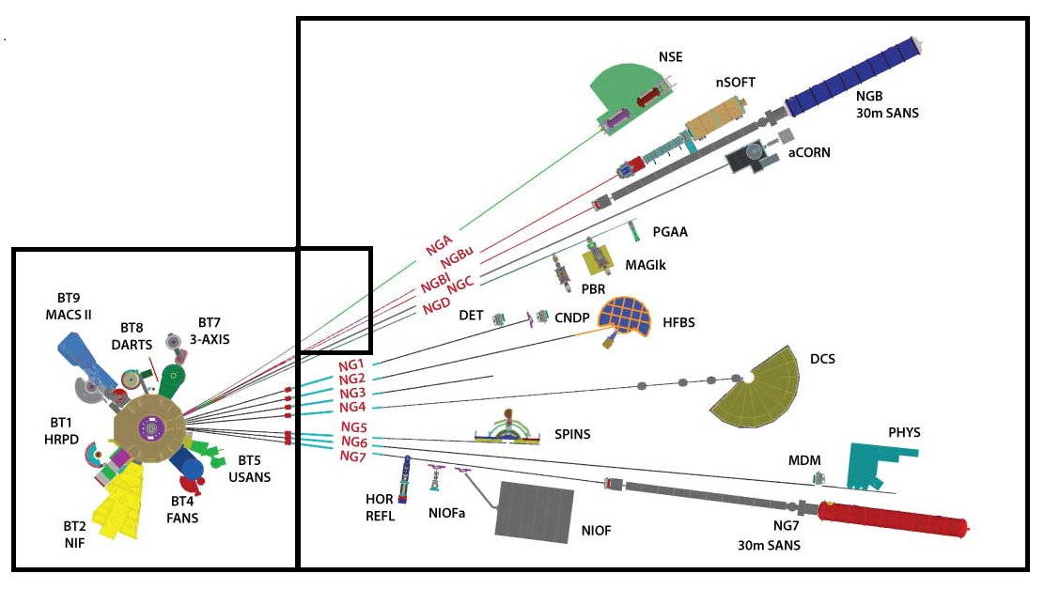
Old Pump House
Old Guide Hall
Reactor Hall
New Guide Hall

Figure 1. Location of NCNR instruments in the expanded Guide Hall. Note that the new guides, A-D, pass through the old pump house, the first floor of which is now full of shielding.

As the SCBP was being built in 2011, the NCNR began a year-long outage to install the guides, the second hydrogen cold source, and the new cooling system for the reactor secondary. Also during this period, the storage pool was emptied of spent fuel and a team of divers stripped the peeling paint from the walls and floor and applied a water-tight epoxy coating, and the fuel transfer system between the reactor vessel and the pool was removed and refurbished. Finally, the outage allowed a major modification to the Thermal Shield Cooling System, eliminating leaks by drawing water through the system under vacuum.

Given that the outage was by far the most ambitious ever undertaken by NCNR, it really proceeded relatively smoothly. It was scheduled for 10.5 months, but lasted 13 months primarily due to unavoidable construction delays in the completion of the SCPB (late start by the contractor and bad weather). Planning for the outage began more than two years in advance. NCNR management had weekly strategy meetings with group leaders and the contractor’s representatives to prepare the staging of all the various projects. Once into the outage, brief meetings were held late every afternoon to coordinate the multiple activities planned for the next day. The daily meetings were very effective at resolving potential conflicts over work space, personnel and equipment (crane usage, for example) as various jobs went off schedule. The major activities are summarized below.

2. Expansion and Upgrade Activities

The outage began April 1, 2011 and ended April 26, 2012 when the next reactor cycle began. The NBSR and the cold neutron sources were operable in mid-March, however, and there were occasional days with several hours of full power tests of the secondary cooling system and the new cold source leading up to the resumption of normal operations. At the time of this IGORR meeting, the NBSR is in the 16th reactor cycle since completion of the outage.

2.1 The Secondary Cooling System

Figure 1 shows that the new guides pass through the old pump house, D-Wing, and would have interfered with 30-inch (76 cm) secondary pipes that were located there. In addition, the old pumps located in the D-Wing basement, would have been very difficult to replace once the guide shields were installed. Thus, the decision to locate the new guides in the CTW beam port necessitated big changes in the secondary system. The SCPB was built adjacent to the cooling tower and new piping from the D-Wing basement was re-routed underground directly to the SCPB. Four 250 HP centrifugal pumps with variable frequency drives (VFD), each with a capacity of 3800 gpm are installed in the SCPB. Generally two or three pumps are needed depending on ambient temperature and humidity.
Also located in the SCPB is a heat exchanger for the cold source refrigerator compressors because the cooling tower is the ultimate compressor cooling heat sink. A branch of the secondary system provides flow to the tower whether or not the main secondary pumps are operating. Either one of the 600 gpm compressor cooling pumps has the capacity to cool one of the existing compressors and one of the new 7-kW refrigerator compressors simultaneously, a requirement for testing the new refrigerator while the existing refrigerator is still in service. The SCPB also contains the equipment for controlling the chemistry of these cooling systems, and backwash strainers for clearing foreign material from the water.

2.2 A Second Cold Neutron Source
Old Guide Hall
Reactor Hall

Lying in the path of the new guides was the cold neutron spectrometer, MACS (Multi-Axis Crystal Spectrometer), located on the beam port CTW as shown in Figure 2. The new guides were installed in CTW, in the same manner as the pre-existing guides NG5-7 were located in CTE. A new LH₂ cold source had to be installed in the thermal-neutron beam port, BT-9, during the outage and MACS was modified and relocated there by the end of 2012. The entire cryostat assembly was less than 15 cm in diameter; the LH₂ vessel itself is only 11 cm OD. A complete description of the BT-9 source was presented at the 2009 IGORR Meeting in Beijing [1]. Figure 3 shows the cryostat assembly prior to insertion into BT-9.
Figure 2. April 2011 layout of the cold source and neutron guides. New guides A-D were installed in CTW, and MACS was relocated to BT-9 (not shown), and now has its own cold source.

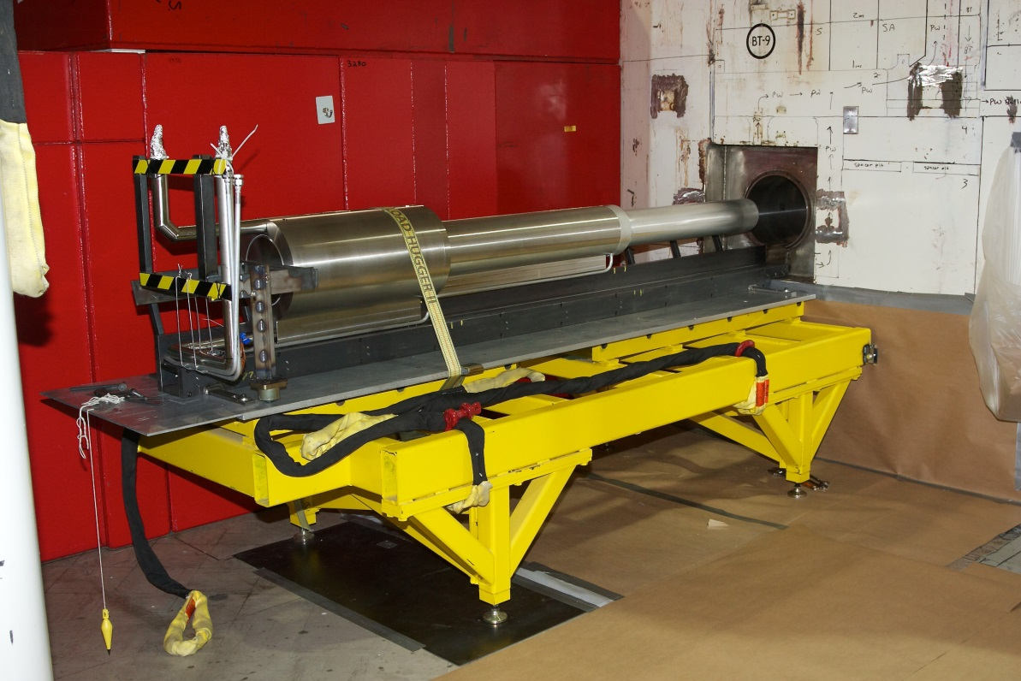

Figure 3. The BT-9 cold source cryostat assembly attached to a stainless steel plug prior to its installation. It is resting on a rail used to guide it into the beam port.

The BT-9 source operated for several cycles during which MACS was modified and installed. A load support structure spanning a gap between thick basement walls was needed to transfer the weight of its shielding from the floor. When MACS-II was commissioned it was confirmed the BT-9 source doubled the cold neutron beam intensity as predicted. The large doubly focusing monochromator (pyrolytic graphite) can deliver up to 5x10⁸ n/cm²-s in a 2x4 cm sample position, providing one of the strongest monochromatic cold neutron beams in the world.

2.3 Thermal Shield Cooling System

The Thermal Shield (TS) of the NBSR consists of layers of lead and steel between the reactor vessel and the concrete biological shield. Heat deposited in it is removed by 188 copper tubes at the Pb/Fe interface. Since these tubes are embedded in the concrete, thermal stresses over the years have caused many to leak contaminated H₂O. Reactor operators spent many hours at the reactor face during each cycle testing each line for leaks and isolating leaking lines from the supply and return headers. Many more hours were spent between cycles treating and re-treating the lines to (temporarily) stop the leaks, with the risk of clogging a line. Too many consecutive isolated or clogged lines would necessitate a reactor shutdown; it was in fact reducing the reliability of the facility.

Borrowing an idea developed at HIFAR in Australia, NCNR studied the possibility of drawing the water through the tubes under vacuum, eliminating the leaks. At the NBSR, however, the gap between the vessel and the TS is purged with CO₂ to minimize ⁴¹Ar releases from the plant. So instead of water leaking out of the tubes, CO₂ would be drawn into the water, creating a low pH solution that would attack the tubes. NCNR engineers found that magnesium carbonate could be used to create a bi-carbonate buffer that would bring the solution back to a neutral pH [2]. A full scale mockup of the TS cooling system, complete with controlled CO₂ ingress, demonstrated the feasibility of the concept. The pumping system, with eductors providing negative pressure (see Figure 4), and new supply and return headers were then installed during the 2011 outage, along with a PLC and software to control the system and monitor flows through all the tubes. Additional monitoring allows for outstanding surveillance and control of the system. The successful implementation of the new TS cooling system has not only relieved the operators of very time consuming and tedious maintenance, it has also significantly lowered their radiation exposures.

2.4 Neutron Guide Installation

As soon as the expansion project was announced, NCNR hosted a workshop for facility users to voice their desires for new and/or improved instruments. Subsequently, the decision was made to install the new guides in CTW and that certain instruments would be modified and moved to the new guide hall leaving some vacancies that would later be occupied by new instruments needing years of development. Custom built curved guides were then designed and fabricated for the instruments to be moved to the new guide hall. Guides A-D are unique, unlike NG1-7 which are nearly identical at 5cm by 16 cm. NG-C, for example, is a ballistic guide (see Figure 5) expanding in size for half of its length to accept as many neutrons as possible but with a higher divergence than would be acceptable for small-angle scattering. NG-B is actually split into upper and lower 5x5 cm sections that curve away from each other to accommodate two SANS instruments (see Figure 6).

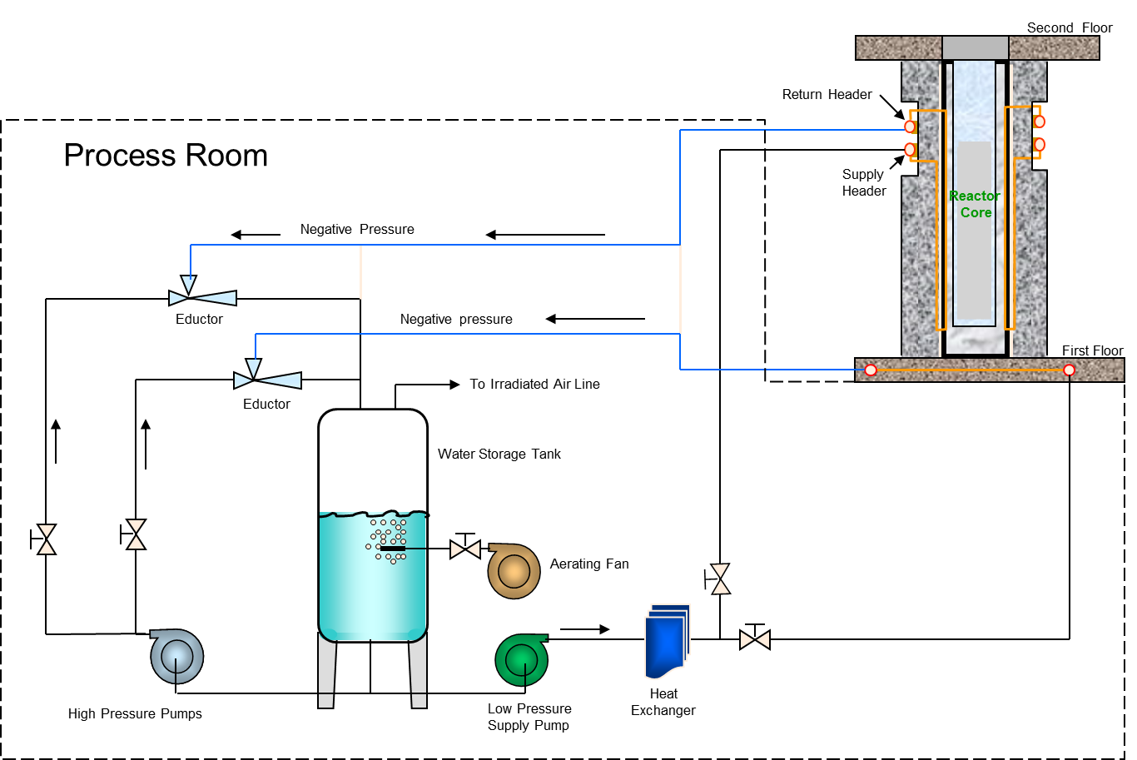

Figure 4. Schematic of the new Thermal Shield cooling System in which water flow is achieved with a partial vacuum eliminating leaks.

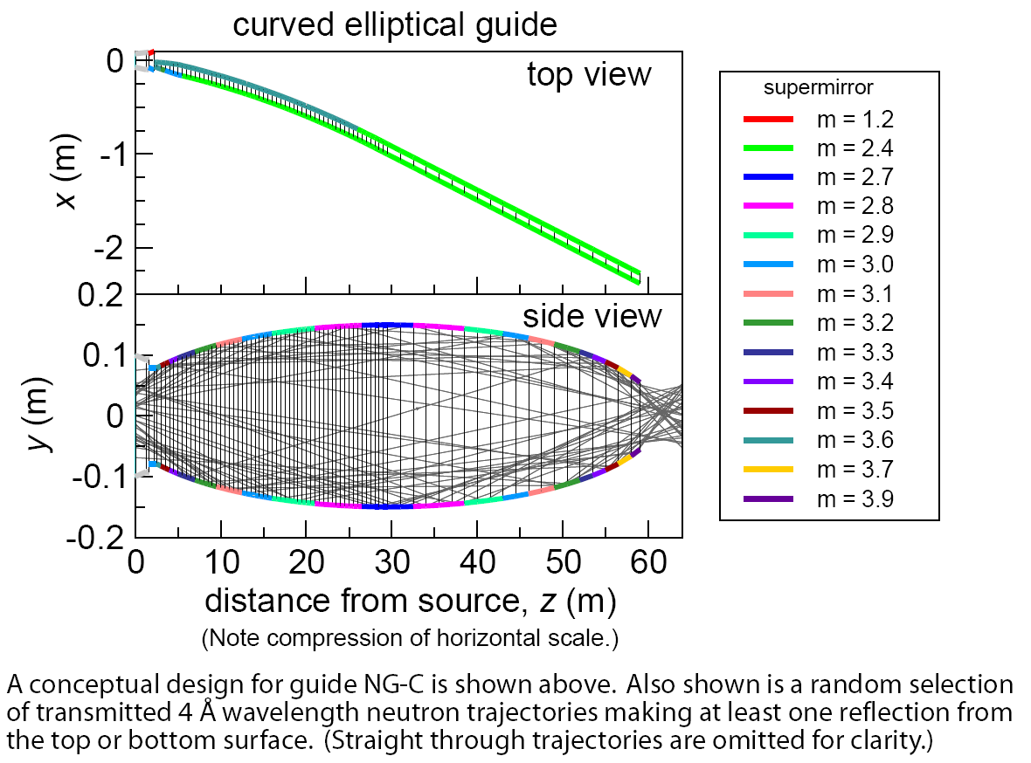

Figure 5. Optics of the ballistic guide, NG-C.

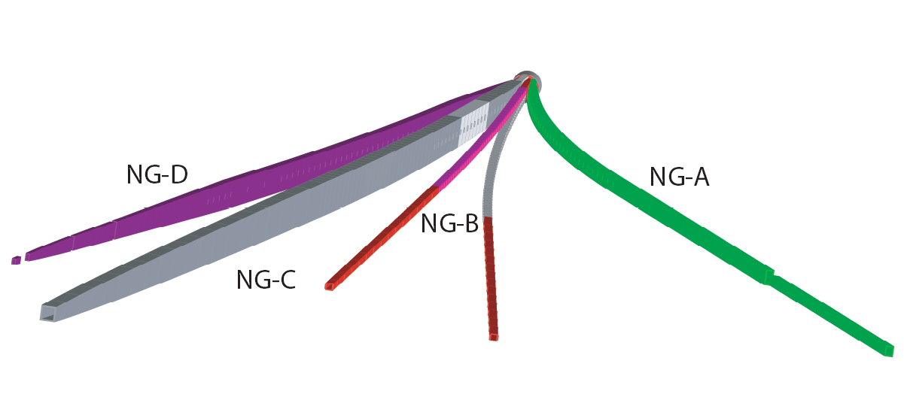
Figure 6. Perspective view of new guides, from the beam ends looking towards the cold source. Note that NG-B splits into upper and lower guides.

NCNR engineers had to procure dozens of guide sections, vacuum casings for the guides, and a very large number of guide shields, and prepare a plan for their installation. The installation stages were highly dependent on crane access because there is a wide area along the location of the former west wall of the old guide hall, now removed, that is not serviced by either of the cranes. Thus the guides and shields were installed east to west in the guide hall often using fork lifts. Most of the guides were received well in advance of the outage, and the staff was able to position the guide sections in their vacuum casings in advance. This work and all of the installation was greatly aided by using a laser tracking system, allowing for relatively quick guide positioning and alignment, both saving time and reducing radiation exposure. (A diary of all this activity has been maintained on the NCNR web page [3] to inform facility users of the progress throughout the outage.)

Very large holes (see Figure 7) were cut through the north wall of the confinement building, between Rooms C-100 and D-100, and through the north wall of the old pump house, between D-100 and the guide hall. D-100 was then filled with cement blocks serving a guide shielding. Only after the guides emerged into the guide hall (see Figure 8), could the reactor be restarted; with the guide shutters closed it was possible to continue guide installation.

2.5 Fuel Storage Pool

Fuel management was a major focus of the advance planning for the outage because the storage pool was to be cleaned and sealed, high-density fuel storage boxes were ready for installation, and the fuel transfer machine was to be refurbished (it had to be removed anyway). A shipment during the middle of the outage removed all of the spent fuel in the pool, and when the reactor core was reloaded, all the partially burned fuel was also removed. Thus, there was no fuel in the storage pool. A diving firm with nuclear power industry experience was contracted to work in the pool. (There is a low concentration of tritium in the pool as a result of fuel transfers from the reactor vessel which is filled with heavy water, and it would have been very costly to store or dispose of the water.) Before the divers arrived, the pool was carefully cleaned to remove any metal fragments remaining as a result of the cutting

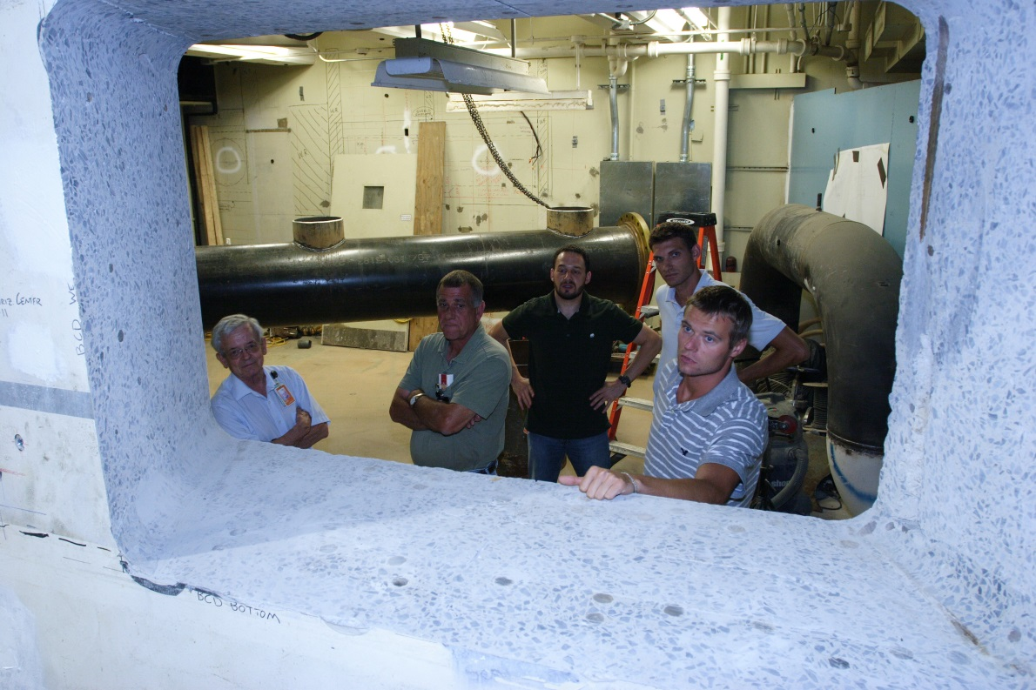

Figure 7. NCNR staff members gaze into the confinement building through the wall penetration for NG-B, NG-C and NG-D. In the background are pieces of secondary piping that had to be removed to make way for the guides.

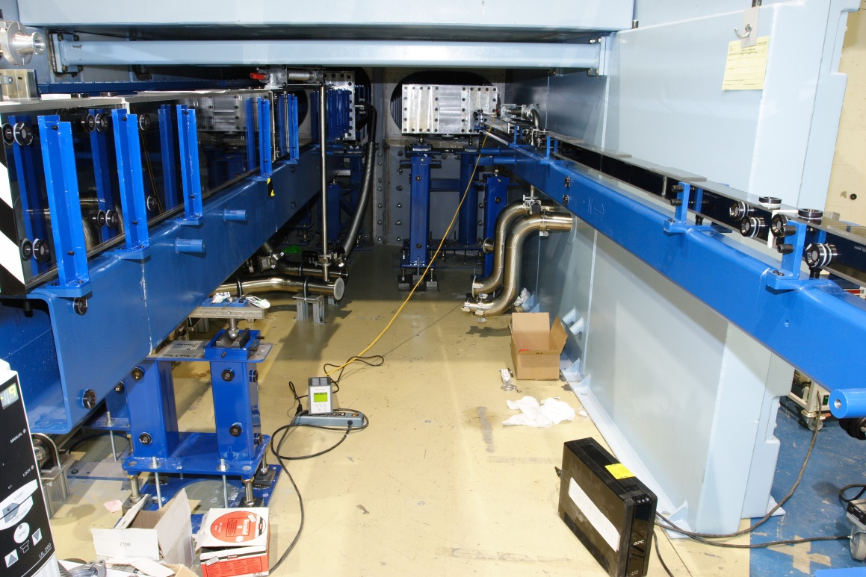

Figure 8. The first few sections of NG-C (left) and NG-B_{lower} being installed in the guide hall. NG-C is a ballistic guide opening to 110x300 mm at its maximum, whereas both of the NG-B guides are 50x50 mm.

of fuel elements with the underwater saw, and the fuel transfer machine was removed and stored in C-200 to be refurbished.

The divers removed the old fuel storage racks and stripped the neoprene primer and hypalon paint originally used to seal the pool, and then applied a water tight epoxy coating. They installed stainless steel plates on the floor and attached the new fuel storage boxes to the plates so as not to disturb the newly applied sealant. Finally the transfer machine was re-installed and the water was treated with peroxide to remove iron reducing bacteria that flourished when the pool water was not being routinely treated and there was no fuel in the pool. The work in the pool took ten weeks, and the cleanup took four more weeks. As a result of the project, the capacity of the pool was increased to 432 cut fuel sections (half elements) and 72 fuel elements, roughly 10 years of spent fuel.

2.6 Compressor Building and Electric Power Switchyard

The NCNR is planning to replace the existing LH₂ cold source, installed in 2002, with a large volume liquid deuterium source [4] in the next few years. A new 7 kW cryogenic refrigerator is being installed because the existing refrigerator does not have the capacity for the LD₂ source. The new compressor building was erected for this purpose and is now occupied by two new 800 kW helium compressors and a large oil removal skid. It is hoped that the new system will be operational by 2016. The building, the switch yard and the new compressor cooling system are all needed to be able to operate the existing refrigerator and test the new one simultaneously. Only when the new refrigerator has passed its acceptance criteria, will the old refrigerator be retired.

3. Instrumentation

As the new guides became available throughout 2012, instruments were installed in the new guide hall in roughly the order of the list in Table 1. Many were modified and upgraded to take full advantage of the new guides. For example, PBR now has a flux three times greater than the old horizontal reflectometer on NG-1, and has advanced neutron polarization capabilities in its new location on NG-D. Most of the relocated instruments have similar gains and/or enhancements. The moves were staged in an effort to minimize the additional loss of beam time for the individual instruments.
Vacancies created in the old guide hall will be filled in the next two years by new instruments still in development. The fundamental physics group is installing aCORN on NG-C (Figure 3), where the cold neutron flux is expected to be about 15 times that of NG-6. Components of the 40 m vSANS will soon be installed on NG-3; it will span the entire length of the guide hall. After considerable work on scintillator detector development, CANDOR is now entering the design/build phase and is expected to be installed in 2016. Detailed descriptions of these and other instruments are posted on the NCNR web pages [5].

Table 1. Summary of Neutron Instrument Modifications.

Instruments in Operation: |  | Location
MAGIK* | Multiple Angle Grazing Incidence k (vector) |  | NG-D
PBR* | Polarized Beam Reflectometer |  | ND-D
nSoft* | 10m Small Angle Neutron Scattering |  | NG-B_{lower}
SANS | 30m Small Angle Neutron Scattering |  | NG-B_{upper}
NSE* | Neutron Spin Echo Spectrometer |  | NG-A
MACS-II* | Multi Analyzer Crystal Spectrometer |  | BT-9
PGAA | Prompt Gamma Activation Analysis |  | NG-D
CNDP | Cold Neutron Depth Profiling |  | NG-D
Instruments in Development:
aCORN* | a CORrelation in Neutron decay |  | NG-C
CANDOR* | Chromatic Analysis Neutron Diffractometer Or Reflectometer |  | NG-1
vSANS* | 40 m very Small Angle Neutron Scattering |  | NG-3
MAD* | Materials Diffractometer |  | NG-5
NPIF* | Neutron Phase Imaging Facility |  | NG-C
* New or Upgraded
4. Conclusion

The NCNR is nearing the end of the Expansion Project launched in 2007. The project included major construction, a prolonged outage, upgrades to many reactor systems, and significant enhancements in the neutron scattering capabilities available to our users. Nearly every member of the NCNR staff was involved in planning and executing the many expansion activities. The reactor upgrades are part of the ongoing effort to maintain the plant in good condition so the NBSR is able to be relicensed in 2029. The cold neutron capabilities have been expanded in response to users of the facility and it is expected that 70-75% of the research at NCNR will utilize cold neutrons when the suite of instruments under development is complete.

5. References

- Kopetka, P., Middleton, M., Williams, R. E. and Rowe, J. M., “A Second Liquid Hydrogen Cold Source for the NIST Research Reactor”, Proc. 12th Meeting of the International Group on Research Reactors, IGORR-12, Beijing, China, October 27-31, 2009.
- Brand, P. B., Norbedo, A. J. and Sprenger, G. S., “NIST Reactor Solves Operational Nuisance Problem Using Novel Application of Vacuum Transfer Technology”, Proc. 15th Meeting of the International Group on Research Reactors, IGORR-15, October 13-18, 2013.
- NCNR Web Page: http://www.ncnr.nist.gov/expansion2/expansion.html
- Williams, R. E., Middleton, M., Kopetka, P., Rowe, J. M. and Brand, P. B., “A Liquid Deuterium Cold Neutron Source for the NIST Research Reactor – Conceptual Design”, Proc. 15th Meeting of the International Group on Research Reactors, IGORR-15, October 13-18, 2013.
- NCNR Web Page: http://www.ncnr.nist.gov/instruments/

