**Operation and Utilisation of Low Power Research Reactor Critical Facility for Advanced Heavy Water Reactor (AHWR)**

S. K. De

Reactor Operation Division, Bhabha Atomic Research Centre, Trombay, Mumbai 400085, India

(Corresponding Author: Email: [skde@barc.gov.in](mailto:skde@barc.gov.in); Phone: +91-22-25591385)

India has large reserves of Thorium and its utilisation for power production is an important feature of the long-term Indian Nuclear Power Programme. As a part of this strategy, an Advanced Heavy Water Reactor (AHWR) has been developed in BARC. Critical Facility (CF) is a low power research reactor with features like “enough flexibility to conduct a wide range of experiments, which helps in validating the computer codes for reactor physics of AHWR and in generating nuclear data about material, such as Thorium – Uranium 233 based fuel, which have not been used extensively in the past”. CF has been designed for a nominal power of 100 W for the average flux of  n/cm2/s. Facility was commissioned and achieved first criticality in April 2008. Since then, it has been utilised for conducting lattice physics experiments for validating the physics design parameters. Towards this, integral experiment with one experimental fuel assembly (U-ThO2 mixed pin cluster, Th-1% Pu cluster, Th-LEU cluster & U-ThO2-U sandwich cluster) at representative pile location was carried out. Graphite reflector position of this reactor has facilities for testing neutron detectors and also to activate samples (Soil, Geological rock, Biological sample and Metallic alloys) for neutron activation analysis (NAA). Large sample analysis is advantageous for obtaining better analytical representativeness instead of replicate sub-sample analysis. This paper will provide an overview of operation and utilisation of the low power research reactor Critical Facility for AHWR.

**1.0 Introduction**

An Advanced Heavy Water Reactor (AHWR) has been designed and developed for maximum power generation from Thorium considering its large reserves. The design envisages using 54 pin MOX cluster with different enrichment of 233U and Pu in Thoria fuel pins. Theoretical models developed to simulate neutron transport and the geometrical details of the reactor including all reactivity devices involve approximations in modeling, resulting in uncertainties. With a view to minimise these uncertainties, a low power research reactor-Critical Facility- was built; in which cold clean fuel can be arranged in a desired and precise geometry [1]. Different experiments conducted in this facility greatly contribute to understand and validate the physics design parameters.

CF is a low power research reactor with a nominal power of 100 W with an average neutron flux of 108 n/cm2/sec. The reactor tank is made of Aluminium in which fuel assemblies are suspended from the top. The reactor tank is located on a bottom support structure. The open space inside the support structure is filled with graphite reflector blocks where the neutron detectors are located. A square box above the reactor tank houses the lattice girders from which the fuel assemblies are suspended *(see ).* The lattice girders can be moved to vary the pitch, i.e., the distance between the two adjacent fuel assemblies *(see )*. These lattice girders also support the reactor shutdown devices. The shut down device is a neutron absorber assembly of Cadmium with a drive mechanism. The top of the square box is closed by a revolving floor, which also permits access to any of the lattice location for handling operations. The joint between the revolving floor and the square box is made using an oil seal which permits the flexibility for rotation of the revolving floor and also maintains the pressure of the inside of the reactor tank within specified range. The radiation shielding at the top is provided by two movable shield trolleys. The shield trolleys can be opened only during reactor shutdown state.

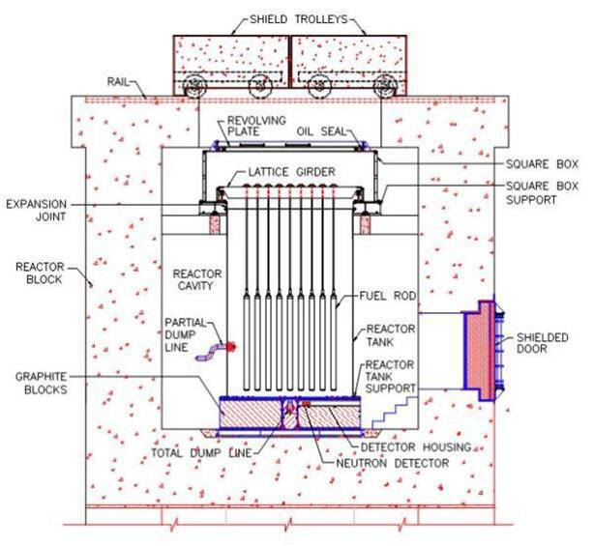

FIG. 1. Reactor Block of AHWR CF.

The CF has provision to study three types of core. The three types of core are based on different fuel types, i.e.

1. 19 pin natural Uranium metal fuel cluster to constitute the reference core;
2. 54 pin (Th-Pu) MOX/(Th-233U) Mox cluster to constitute the representative AHWR core;
3. 37 pin natural Uranium oxide fuel cluster to constitute the 540 MWe PHWR core.

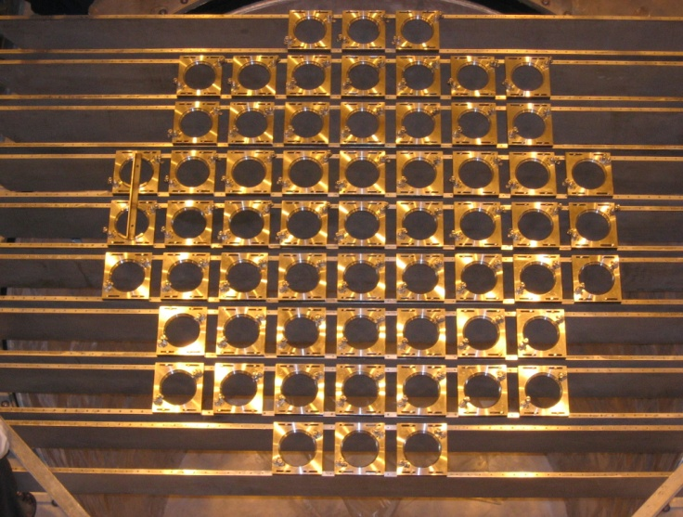

FIG. 2. Lattice girder of AHWR-CF.

Initially the reactor core is configured with natural Uranium fuel assemblies and later the AHWR type fuel assemblies will be loaded into the core. Heavy water is used as moderator. As the reactor power is very low, no dedicated core cooling system is required.

**2.0 Operation & Experiments**

The facility was made critical in April 2008 and since then it has been operated for different experimental purpose. Observed critical height (226.7 cm) was very much close to estimated critical height (226.5 cm).

To validate the design intent of the reactor, following experiments were carried out [2];

1. Measurement of Shut Off Rod (SORs) worth: Dynamic test was performed for checking the total worth of SORs by tripping the reactor on manual scram. The analysis of power changes indicate that the worth of all Six SORs dropping together is 103 mk. The evaluated shutoff rod worth for reference core is 105.1 mk. The worth of individual shut off rod was also measured by sub-critical method. The measured worth of each individual shut off rod was found to be about 11 mk against the calculated value of 12 mk.
2. Absorber Rod (AR) calibration: Total measured reactivity was found to be 3.6 mk against the calculated value of 3.7 mk. Variation of the reactivity load with position of AR was also determined.
3. Level coefficient measurement at critical height: Measured value of level coefficient was found to be 0.049 mk/mm whereas the evaluated figure was 0.05 mk/mm.
4. Moderator Temperature Coefficient was measured and found to be 15.7 pcm/⁰C.
5. Axial neutron flux distribution was measured using copper wire as an activation detector. The profile was found to be bottom peaked cosine. Graphite (around 30 cm height) placed at the bottom of the reactor as neutron reflector is the reason for this peak.
6. Neutron Spectrum was measured on the surface of central cluster using multi foils activation technique.
7. Fine structure flux profile was measured inside the central fuel cluster. Activation foils were kept inside the [dismantlable](https://www.google.co.in/search?es_sm=122&q=dismantlable&spell=1&sa=X&ei=BFlEVJn9I6aPmwW41YC4BA&ved=0CBoQBSgA) fuel cluster *(see )*. Flux disadvantage factor (1.85) was obtained using the fine structure profile.
8. A pin of natural Uranium and Thorium was irradiated and gamma activity was measured to get the axial fission power profile.

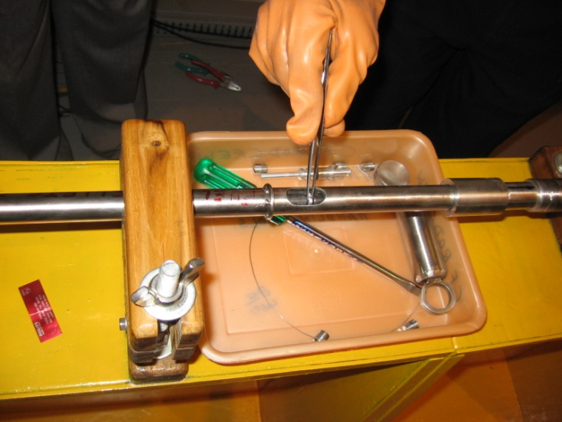

FIG. 3. Activation foils being installed within the fuel pin for measurement of fine structure flux profile.

There is a significant variation of Thorium cross section in different nuclear data library. This variation can be studied by carrying out the integral experiment with Thorium based cluster and by comparing the results with calculated values of integral parameters obtained using different nuclear data libraries. Following integral experiments were carried out in CF.

1. Integral Experiments with Mixed pin [ThO2-U] cluster: Critical height was measurement with one [ThO2-U] mixed pin cluster in the central location E5 and five other locations of reference core.
2. Fine structure flux measurement inside the central lattice (E5) with mixed pin thoria cluster.
3. Integral Experiments with six pin [Th-1%Pu] cluster: Critical height measurement with one [Th-1% Pu] six pins cluster in the central location E5 and five other locations of reference core.
4. Integral Experiments with six pin [Th-LEU] sandwich cluster: Critical height measurement with one [U-LEU] six pin sandwich cluster in the central location E5 and five other locations of reference core.
5. Integral Experiments with nineteen pin [U-ThO2-U] sandwich cluster: Critical height measurement with one [U-ThO2-U] nineteen pin sandwich cluster in the central location E5 and five other locations of reference core.

Estimated and observed critical heights for different integral experiments are summarized in TABLE I.

Table I: Estimated and observed critical heights for different integral experiments carried out in CF

|  |  |  |  |  |  |  |  |
| --- | --- | --- | --- | --- | --- | --- | --- |
| **Cluster Type** | **Critical height (cm)** | **E-5** | **F-4** | **F-3** | **F-2** | **B-3** | **F-1** |
| **ThO2-U Mixed pin** | Evaluated | 238.5 | 237.3 | 234.9 | 231.8 | 230.3 | 229.5 |
| Observed | 237.8 | 237.0 | 234.7 | 231.1 | 229.9 | 229.0 |
| **ThO2 -1% PuO2** | Evaluated | 232.9 | 233.5 | 232.3 | 229.9 | 229.6 | 228.9 |
| Observed | 233.3 | 233.4 | 231.7 | 229.8 | 229.5 | 229.0 |
| **ThO2-LEU** | Evaluated | 234.2 | 234.7 | 233.2 | 230.9 | 230.4 | 229.6 |
| Observed | 235.2 | 235.6 | 234.4 | 231.7 | 231.4 | 230.5 |
| **U-ThO2-U sandwich** | Evaluated | 236.8 | 235.3 | 232.3 | 228.3 | 226.7 | 225.2 |
| Observed | 235.2 | 234.1 | 231.5 | 227.9 | 226.5 | 225.3 |

Results of the experiments carried out with all natural Uranium clusters enhanced the confidence in the methodology and computational tools. Measured values were found to be in good agreement with the calculated ones obtained by in-house developed computational tools. Measured critical heights in the integral experiments with Thorium based experimental cluster were found close to the calculated values. Carrying out an experiment in a reactor involves so many steps right from the safety clearance of the proposal up to the analysis of the results. Experience gained in the experiments conducted in reference core (19 pin natural Uranium clusters) will be useful in planning and conducting the experimental program in CF with AHWR fuel clusters.

**3.0 Other Utilisation of CF**

The main objective of this reactor is for conducting experiments and validating the physics design parameters of AHWR. Graphite reflector position of this reactor has facilities for testing neutron detectors and also to irradiate samples (Soil, Geological rock, Biological sample and Metallic alloys) for neutron activation analysis (NAA).

**3.1 Neutron Activation Analysis (NAA)**

NAA is one of the most widely used techniques for trace, minor, major elemental concentration determination in different samples due to properties like simultaneous multielement capability, high sensitivity, high selectivity, negligible matrix effect and non-destructive nature. Large sample analysis is advantageous for obtaining better analytical representativeness instead of replicate sub-sample analysis.

Large size samples (1 to 500 g) were packed in polythene. Small samples (100 to 500 mg) were also used. Samples were irradiated in graphite reflector position of CF for 4 h *(see )*.

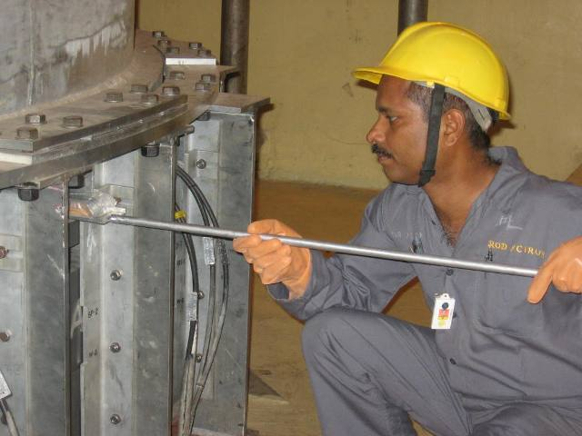

FIG. 4. Samples being installed in the graphite reflector region for irradiation.

During irradiation of samples in CF, higher masses of the samples were used. This obviates the error due to inhomogeneous distribution of analytes in small sub samples. The overall radiation doses in the irradiated samples after irradiation were less due to low neutron flux in the irradiation position.

Concentrations of Fe, Cr, Ni, Mo, Mn, and As were determined in the austenitic stainless steel (using a sample of 5 g mass). The results obtained are in good agreement (within ±5%) with its certified values.

Ancient potteries, bricks obtained from excavated Buddhist sites of Andhra Pradesh, India were analyzed. Large size (50 to 100 g) sample neutron activation analysis (LSNAA) of dross from Government Mint, Mumbai was carried out. Analysis of varying masses were used to arrive at representative size for analysis, which indicated representative sample size of 2 g. Concentrations of Au and Ag were found to be in the range of 200-400 mg kg-1 and 1200-1700 mg kg-1 respectively in the three different samples.

Photographs of a few samples irradiated in CF are illustrated below *(See )*.

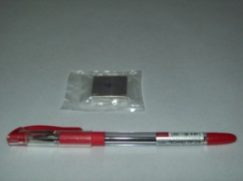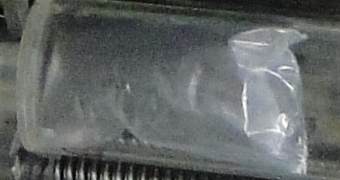

FIG. 5. Photographs of samples analyzed for neutron activation.

Concentration ratios of elements such as Na, K, Cr, Mn, Fe, Co, Zn, As, Rb, Cs, La, Ce, Sm, Eu, Yb, Lu, Hf and Th with respect to Sc (internal mono standard) were calculated in the IAEA intercomparison sample. The results are in agreement with small size sample analysis by NAA [3].

**3.2 Detector Testing**

The characterization of neutron detectors for reactor use requires facility where the detectors could be exposed to neutron flux mainly thermal over wide range. The typical flux range for this purpose varies from 0.01 nv to anything of the order of 1011 nv. The AHWR-CF has been used for following main categories of detectors [4]:

1. Boron lined proportional counters (0.1cps/nv to 30cps/nv)
2. Fission counters
3. High sensitivity (3He) counters
4. Ion Chambers (Compensated/Uncompensated)

The AHWR-CF has two thermal flux locations at bottom graphite reflector region which are used for housing the test detectors. The maximum flux at these locations is of the order of 2 x 107 nv at 50 W operation of the reactor. These locations are therefore used for characterizing the detector performances of pulse detectors. The facility has the flexibility to maneuver the reactor power from shutdown power level to full power in finer steps of even 20 µW at lower power levels. This enables establishing the detector performance range very critically. The various parameters that are tested typically for pulse detectors are listed below:

* Discriminator Bias characteristics.
* HV characteristics.
* Linearity of the flux measurement range.
* Neutron sensitivity
* Gamma discrimination
* Long term count rate stability
* Response time and repeatability of detector response.
* Measurement of count rate loss at high neutron flux.
* Performance immediately after exposure to high nvt at high flux

However, for DC detectors, the full measurement range may not be covered due to limited neutron flux at these locations. The DC detectors are checked for their response and initial signal calibration characterization.

The designated locations (J-8) at the in-core position are also used for conducting detector life tests for high fluence with incident flux of the order of 108 nv. These locations can house the detectors for long duration and thereby characterizing the detectors of particular design for cumulative exposures under various detector bias conditions.

**4.0 Final Remarks**

In a series of experiments, integral experiment were carried out using experimental fuel assembly (U-ThO2 mixed pin cluster, Th-1% Pu cluster, Th-LEU cluster & U-ThO2-U sandwiched cluster) at representative pile location. Results of the experiments carried out enhanced the confidence in the methodology and computational tools. Measured values were found to be in good agreement with the calculated ones obtained by in-house developed computational tools. Apart from reactor physics experiments, facility is used to test and calibrate the neutron detectors. Also it is used to activate the samples (Soil, Geological rock, Biological sample and metallic alloys) for neutron activation analysis (NAA).

**5.0 Acknowledgments**

Author thanks Shri R. C. Sharma & Shri D. K. Shukla, Reactor Group of Bhabha Atomic Research Centre for recommendation in participation of IGORR-2014. Author also thanks Shri V. M. Jolly & Shri S. K. Verma, Critical Facility Operations; Shri Debashis Das, Electronic Division; Shri Rajeev Kumar, Reactor Project Design Division, Shri Kallol Swain, Analytical Chemistry Division of Bhabha Atomic Research Centre for their cooperation to prepare this paper.

**6.0 References**

1. V. K. RAINA, R SRIVENKATESAN, D C KHATRI AND D K LAHIRI, “Nuclear Engineering and Design”, 236 (2006), pp 758–769.
2. REPORTS ON EXPERIMENTS CARRIED OUT IN CRITICAL FACILITY Of Reactor Physics Design Division, BARC from 2008 -2014.
3. K. B. DASARI, R. ACHARYA, K. K. SWAIN, N. LAKSHMANA DAS AND A. V. R. REDDY; J. Radioanal. Nucl. Chem., 286 (2010) 525–531.
4. QUARTERLY PROGRESS REPORT of Electronic Division, BARC, from 2010 – 2012.