Relicensing of the SM1 Sub-critical assembly of the Pavia University

D. Alloni^{1,3}, M. Oddone^{2,3}, S. Manera¹, M. Prata^{1,3}, A. Salvini^{1,3}, L. Strada^{2,3}

- LENA, Laboratory of Applied Nuclear Energy, University of Pavia, Via Aselli 41, 27100, Pavia, Italy
- Chemistry Department, University of Pavia, Via Taramelli 12, 27100, Pavia, Italy
- National Institute of nuclear physics, (INFN)

Corresponding author: lucilla.strada@unipv.it

Abstract. SM1 is a thermal Sub-critical Multiplication complex located at the University of Pavia (Italy) and, since its installation in 1962, has been utilized mainly for radiochemistry research and educational purposes. We present the relicensing process, in compliance of new directives and national legislation, describing the organization and its purpose. Together with the request of licence will be presented the safety assessment following the Code of Conduct applied to a sub critical assembly. A full facility description is also presented.

- Introduction
The SM-1 assembly is installed at the Radiochemistry area of the Department of Chemistry, University of Pavia. SM1 is a thermal sub-critical complex moderated with light water. Fuel elements are assembled in a hexagonal prism geometrical configuration with a radial dimension of 114 cm and a height of 135 cm. The fuel is natural uranium in metallic form with 206 Aluminum-clad fuel elements with an inner diameter of 2.8 cm and a length of 132 cm. Each fuel element is filled with five metallic uranium ingots of cylindrical shape. Fig. 1 shows SM1 assembly where, at the center, it is located the Pu-Be neutron source. The casing of the core tank is made of aluminum filled up with paraffin (20 cm thickness) and the total fuel weight is 2068 Kg.

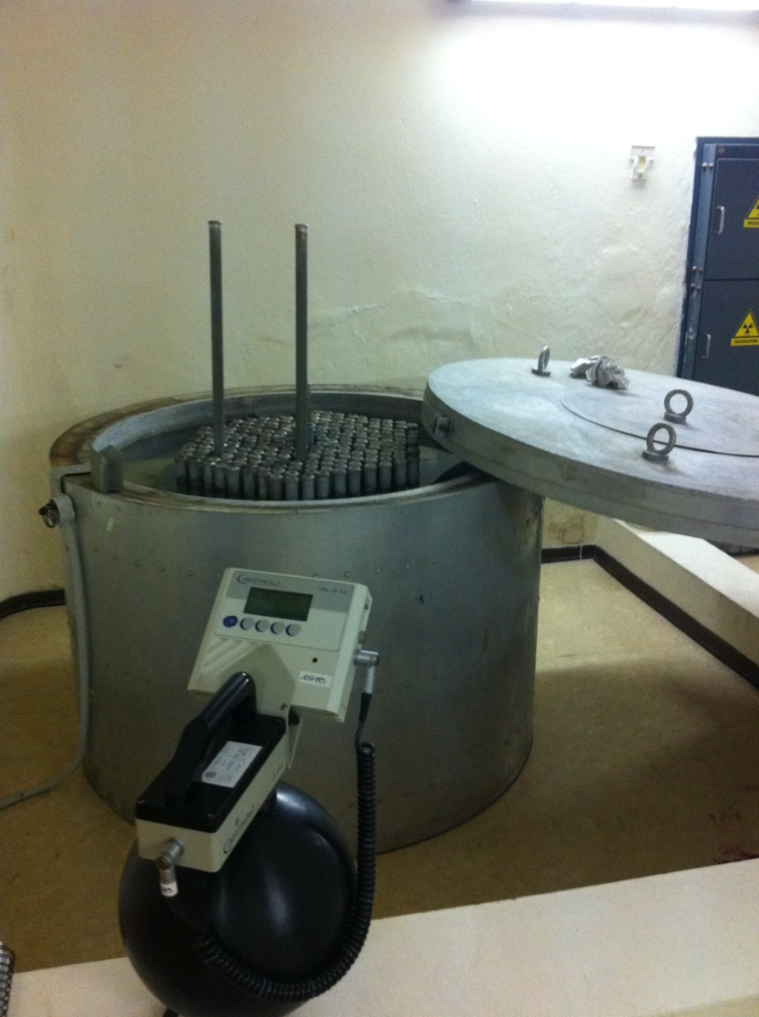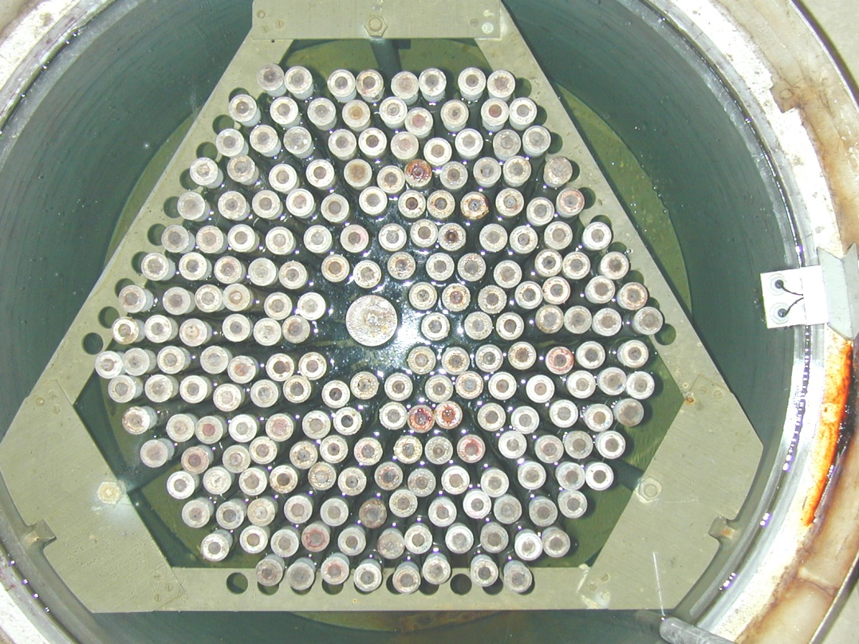

Figure 1: lateral (left) and top view (right) of the SM1 assembly.

The subcritical assembly is installed in a basement room of 6.00x7.60 m and the assembly itself is placed in a corner of the room, in a pit 50 cm below the level of the floor, protected on the outside of the room by a wall in barytic concrete (20 cm thick and 180 cm height) and toward the room by a wall in barytic concrete (thickness 20 cm and height 75 cm). Behind the protection wall it is also placed the container of the neutron source. The room that houses the subcritical assembly does not have any containment except a a containment tank to eventually accommodate the water spilled from the tank. The characteristics of the assembly shall ensure sub-criticality for which there is no need for control and regulation.

- Request of licence update
The last operating licence was issued in accordance with Art. 11 Law of 31 December 1962 n.1860. Today, update of the licence is requested in compliance with Italian legislation D.Lgs 17 March 1995 n.230 art. 52, implementation of 89/618/Euratom, 90/641/Euratom, 92/3/Euratom e 96/29/Euratom directives. The present authorization released by the Italian Ministry of Economic Development (Prot. n. 000015521 dated 26 July 2013) foreseen a periodic safety assessment for the subcritical SM-1 multiplying assembly of the University of Pavia [1]. The assessment takes into account the recommendations of the "Code of Conduct on Safety Research Reactors" [2] approved by the IAEA Board of Governors in March 2004 and approved by the General Conference in resolution GC (48) /RES/10.A.8 in September 2004. The Rector of Pavia University, as owner, submits the request of update of the licence to the Italian Ministry of Economic Development together with update of safety assessment, referring to the appropriate article of law and to the update of plant documentation (Operational limits and conditions, Radioprotection Instructions, Technical Report on the Condition and Operation, Operating Instructions, Emergency plan). Furthermore, in order to describe the facility’s behaviour and draw up a strategic plan, a full characterization was performed.

- Safety assessment update

The University of Pavia has worked over the years in accordance with Italian law and the International Guidelines [3,4] and, in particular, has carried out the assessments and studies necessary for the preparation and approval of an Activity Plan. Periodically through the Nuclear Safety Committee, a continuous review was carried out for the safety of the plant, its state of preservation and its use. Any technical change of the equipment installed relevant to nuclear safety and radiation protection, has been continuously documented, communicated and placed on the approval as plant modification in accordance with the approved System Management.

  - Design, installation and plant licence

The SM1 assembly plant is operated in compliance with its operating licence and with the system requirements, surveillance standards and local regulations. Since the first release of the operating licence, considering the subsequent renewals in 1990, the release of the operating licence and finally the five-year extensions, the owner has demonstrated that the objectives and criteria for the design of structures, systems and components relevant to safety purposes have been achieved.

  - Organization and human resources

The University of Pavia is responsible for the financial support in order to maintain safety, continuous improvement of systems, human resources and their continuous training. The guidelines recommend considering the capabilities and limitations of personnel in normal operating conditions and emergency situations including what is related to experimental work. The reference documentation includes the duties and responsibilities of each figure operating in these conditions. The staff is trained and kept up to date continuously.

  - Radioprotection and emergency

The radiation protection program is indicated by the Qualified Expert and endorsed by the plant management with the document "Health Physics Regulations". The application and implementation of the operational aspects are delegated to the facility’s Health Physics Service.
The Health Physics Regulations deal with and keep up to date the radiological risk assessment on the basis of the latest plant and instrumental information available, including the risk of interference to other concurrent tasks and provide the tools to improve enforcement procedures. These standards must be brought to the attention of the staff that is required to comply with them.
The LENA External Emergency plan [5], approved and updated in June 2010, is the one of the Nuclear Pole of the University of Pavia; while the internal intervention plan for the SM-1 assembly [6,7] - approved on June 29, 2012 - describes the organization with the duties and responsibilities of the various planned professional figures.

  - Operating, use and realization of experiments

The main activity in SM1 plant is the operation of the reactor for the preparation of short- and medium-lived radioisotopes for experiments in the field of Radiochemistry and measurements of the neutron flux through neutron capture reactions. The planning activities and irradiation experiments are recorded in accordance to documented procedures. In particular, they are kept up to date through the drafting of reports of meetings, through the continuous monitoring of project phases and / or through the issuance of specific procedures and / or their revision.
The operation of the plant is subject to compliance with all statutory and regulatory requirements related to nuclear health and safety, as well as the specific applicable legislation. In particular, the activities of irradiation and conduction of experiments, in their design phase and implementation, take account of:
• All requirements of law and regulations applicable to the operation of a nuclear installation and management of radioactive material;
• Historical information, including records, determined from previous operational experiences and experiments at the plant;
• Functional requirements, such as physics and control of nuclear installations, as well as the requirements for facilities and equipment that may affect the quality of operation or radiation;
• Established procedures for the implementation of activities,
• The competence required to the staff for specific tasks in the process of operation or irradiation
• Implicit requirements;
• The requirements of users, depending on the different types of users;
• Available resources.

All requirements are periodically reviewed in order to verify the adequacy, completeness and absence of ambiguity and conflict. Proposed activities irradiation and / or realization of experiments are examined by the operating personnel and subject to review by the committee for the safety of the plant (Nuclear Safety Committee, Technical and Scientific Committee).

  - Maintenance, modifications, installation, testing and surveillance activities

The maintenance program includes all the services and activities necessary to ensure the plant safety. All maintenance activities related to the operation of the reactor are carried out by two different sections, as indicated Operating Limiting and Condition, approved by the Regulatory Body. Maintenance, testing and monitoring include periodic tasks in order to ensure the safety and operability of systems, equipment and components thus keeping them in efficient operating condition. Scheduled maintenance and tests activities are planned and implemented in accordance with documented procedures transmitted to the Regulatory Body. Additional support activities, not strictly related to nuclear safety, but nevertheless necessary for the proper operation of the plant structures and components are, however, documented and implemented in accordance with the procedures and working instructions included in the internal system of quality management.
The corrective maintenance activities are managed through documented procedures in order to operate safely; in particular, the approval chain of activities includes the approval of the Management and, where appropriate, the one of the Nuclear Safety Committee. The Board is constituted in accordance with the provisions of the law and is composed at least of four members chosen among the technicians who oversee the essential services for the operation of the system and the Qualified Expert.
The changes of the system are managed in accordance with current legislation with particular reference to the method of managing the facility issued by Regulatory Body. For special maintenance activities and specific maintenance contracts, external suppliers are selected, evaluated and qualified according to documented procedures. Regarding the maintenance of systems not related to safety issues the service is provided by the University of Pavia. All workers involved with the external plant systems, are informed about radiation hazards and equipped with all necessary personal devices for radiation protection (e.g., gloves, overshoes, etc.). Each person who accesses the external Controlled Zone, in order to work, receives a dosimeter for absorbed dose monitoring. Specific training is organized for workers depending on the complexity and duration of the activity.
All activity records are stored and recorded at the facility in accordance with the management procedure of documentation and in order to ensure traceability, the assessment of the state of the system and the long-term planning related to the plant aging.

- SM1 nuclear parameters: MCNP and experimental neutron flux and effective multiplication factor evaluation of the complex

A full characterization of the assembly through the evaluation of the neutron flux distributions and effective multiplication factor was performed by means of the Monte Carlo code MCNP [8] in the actual core configuration. Experimental measurement of neutron flux for benchmarking inside two specific irradiation channels was also performed. Comparison between experimental and Monte Carlo results is presented below.
Since the subcritical assembly is well below criticality (i.e. k_{eff} < 1) the SDEF input card mode (i.e. fixed source mode) was used to model the neutron source and the neutron transport inside the lattice. The value of the effective multiplicative coefficient k_{eff,T} (where the subscript T stands for Thermal) of the complex in the thermal configuration was computed using the following equation:

$$k_{eff,T}≈k_{eff,T}^{FS}=\frac{N-1}{N-\frac{1}{\overline{ν}}}$$

where N is the Net Multiplication Factor (given by the output of each Monte Carlo run) defined by the relation (ref MCNP):

$$N=1+G_{f}+G_{x}$$

where $G_{f}$ is the gain in neutrons from fissions, $G_{x}$ is the gain in neutrons from non-fission multiplicative reactions, and $\overline{ν}$ is the average number of emitted neutrons per fission (the superscript FS in the formula above) indicates the Fixed Source mode. All three parameters were evaluated by MCNP and a value of k_{eff,T} = 0.88±0.01 was obtained which was in good agreement with the historical data reported in the licensing documentation of the facility which indicates a value of k_{eff,T} = 0.86.
In order to validate the Monte Carlo simulations of the SM1 complex in its thermal-neutron configuration, measurements of the neutron flux distribution inside the irradiation channels of the complex have been performed by means of the foils activation and spectrum de-convolution technique based on the code SAND II [9]. Two irradiation positions inside the SM1 complex, whose positions are indicated in Figure 3, were available for measurements. Considering the irradiation and measurement time optimization as well as radiation protection constraints, the following target were selected

¹⁹⁷Au + n → ¹⁹⁸Au → ¹⁹⁸Hg* → ¹⁹⁸Hg + γ
t_{1/2} = 2.7 d, Eγ= 411 keV

⁶³Cu + n → ⁶⁴Cu → ⁶⁴Ni* → ⁶⁴Ni + γ
t_{1/2} = 12.7 h, Eγ=511 keV

The calculated specific activities at saturation A_(spec-sat) for both gold and copper reactions, have then been used as input data for the SAND II program. Results of the comparison between simulated and measured neutron flux are presented in Figure 2 and Table 1. Further details can be found in [10].

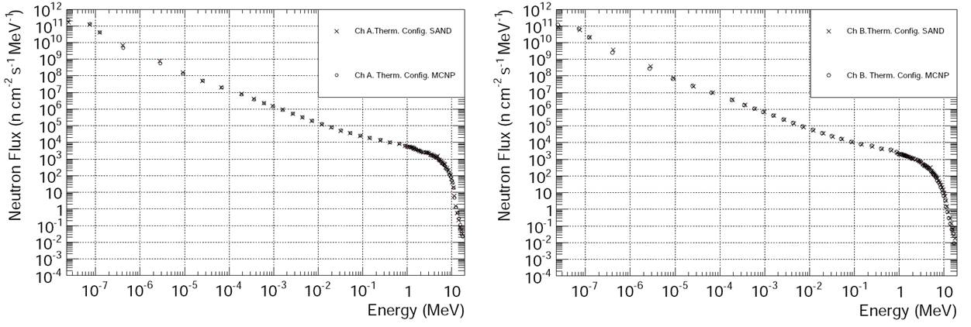.
Figure 2: Comparison between measured (cross symbols – obtained by processing experimental data with SAND II code) and simulated (circles – MCNP simulation results) differential neutron fluxes (Channel A and B) for SM1 in the actual configuration. Errors are standard deviations and are limited to the symbols.

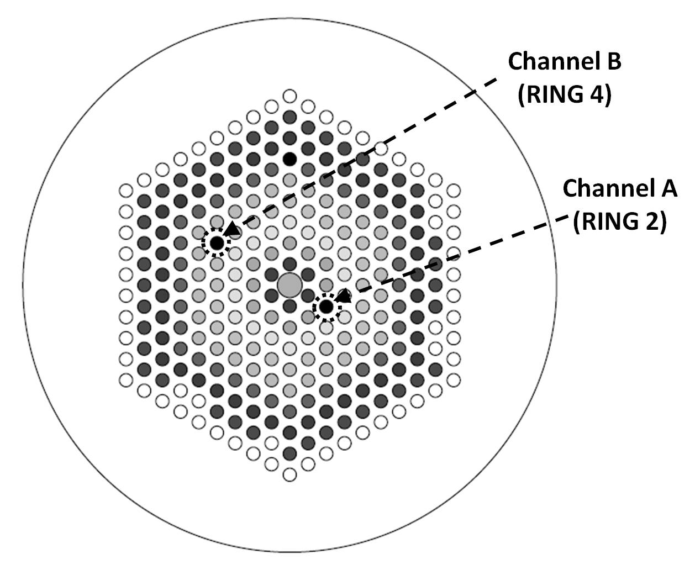
Figure 3: Sketch of the SM1 core with irradiation channels.

Irradiation channel | Exp Integral neutron flux (SAND)  cm⁻² s⁻¹ | Simulated Integral neutron flux (MCNP) cm⁻² s⁻¹
A | (5.9± 0.2)x 10⁴ | (5.716± 0.004)x 10⁴
B | 2.59 ±0.08)x 10⁴ | (2.573± 0.003)x 10⁴

Table 1: Comparison between measured and calculated integral neutron fluxes in the two experimental channels. Errors are standard deviations.

References

[1] Università degli Studi di Pavia - Dipartimento di Chimica Generale. Struttura moltiplicante sottocritica SM-1. Rinnovo dell'autorizzazione all'esercizio (art. 11 della L. 31.12.1962, n.1860). Prot. n. 0015521del 26 luglio 2013.
[2] Code of Conduct on Safety of Research Reactors, IAEA, 2006.
[3] Guidelines for the Review of Research Reactor Safety, IAEA Service Series No.1, IAEA,
1997.
[4] Safety of Research Reactors, IAEA Safety Standards Series No. NS-R-4, IAEA, 2005.
[5] Revisione dei Presupposti Tecnici del Piano di Emergenza Esterna Relativa al Reattore Triga MARK II, da 250 kW, Università di Pavia, 1989.
[6] Piano di intervento per la Struttura Moltiplicante Sottocritica -SM-1, Università di Pavia. Prefettura di Pavia, del 20 giugno 2012, prot.16170.
[7] STRUTTURA MOLTIPLICANTE SOTTOCRITICA SM-1 DELL’UNIVERSITA’ DI PAVIA, Regolamento di Esercizio e Modalità Gestionali, Pavia 2014.
[8] MCNP: J.F. BRIESMEISTER, Editor, "MCNP - A General Monte Carlo N-Particle Transport Code" LA-12625, Los Alamos National Laboratory (1993).
[9] SAND II Manual, Radiation Safety Information Computational Center. Oak Ridge National Laboratory,1965.
[10] D. ALLONI et al, Neutron flux characterization in the SM1 Sub-critical Multiplying complex of the Pavia University , Progress in Nuclear Energy, 67 (2013) 98-103.

