Diving in the pool of a Research Reactor
Inspection of the natural convection valves of the primary circuit of OSIRIS reactor during summer outage

J.S. ZAMPA¹, G. BARRACHIN²

1) Commissariat à l’Energie Atomique
OSIRIS reactor, DRSN/SEROS
CEA Centre de Saclay,
91191 Gif-sur-Yvette – France

Corresponding author: jean-sebastien.zampa@cea.fr

Abstract. The last inspection of OSIRIS convection valves took place in summer 2013, during the reactor summer outage. Non-Destructive-Testing (NDT) techniques were used such as video inspections, gamma radiography and eddy currents. It was a challenge to have these operations realised in the pool of OSIRIS nuclear reactor by professional divers at an approximate distance of 3 meters from the reactor core.

The work was done and organised under the responsibility of the Atomic Energy Commission by the Experimentation and Waste Section of OSIRIS reactor. The inspections were realised by a joint venture of four companies, each specialist in its own field of activity like nuclear worksite organisation, industrial diving, gamma radiography and eddy currents.

An important preparation work had to be carried out before this intervention. A full size stainless steel mock-up of the valves with pre-established defects had been constructed and used to train the divers to radiography and eddy currents techniques. The first tests took place above the surface, then a series of dives was realised in a swimming pool with diving equipment to qualify the processes underwater. The efficiency of the communication between divers and NDT specialists conducting the operations from the surface was also an important point at this stage.

The intervention in OSIRIS was performed by a group of five divers and eight other specialists in September 2013. 25 dives corresponding to 20 hours underwater were necessary to fulfil the inspection program in a three weeks period. Important precautions were constantly taken to minimize the risk of radioactive contamination of the divers, their co-workers and to maintain the level of irradiation during the interventions as low as reasonable.

At the end of the project, no case of contamination was reported and the integrated collective irradiation dose received by the divers was extremely low (0,062 mSv). The results of the inspections were very satisfactory in term of quality and positive in terms of health of the welds. The final report came to the conclusion that there was no damageable defect of the inspected welds.

1. Introduction
The primary circuit of OSIRIS reactor is equipped with two underwater valves. An inspection of the welds of the branch of connecting line of these valves was performed in September 2013 during the summer outage of the reactor.

2. Inspections technique
In addition to a visual inspection two techniques of Non Destructive Tests (NDT) were chosen for this inspection:
- Eddy currents,
- Gamma ray radiography.

The access to the welds was a difficulty: OSIRIS convection valves are located on the primary circuit of a nuclear reactor. Their respective depth is 8,9 and 7,6 meters under the surface of the pool. Their distant to the core of the reactor is approximately of 3 meters. Performing such an operation was a challenge.

Several techniques to proceed to these inspections were considered:
- An offsite inspection of the welds was not a possible option because the convection valves and connecting pipes are integrated parts of the primary circuits of the reactor.
- Emptying the pool of OSIRIS was not a suitable solution either: Such operation would necessitate removing every spent fuel element and every irradiative item not only located in the area of the welds to control, but also from the entire pool of OSIRIS. The temporary storage of these elements would have been a first problem. The suppression of the protection against ionizing radiations provided by water of the pool could also have cause a significant increase of the radiological ambiance in the reactor building. The temporary storage of the water removed or its evacuation would also have been a problem to solve.
- The realisation of underwater inspections appeared to be the best solution. It must be pointed out that OSIRIS already had experiences of divers’ interventions, mainly for the periodic inspections of the reactor decay tank.

The Experimentation and Waste Section of OSIRIS reactor was in charge of the project management of this task and of the coordination with other activities realised in the reactor. A consortium, gathering four contractors was created. These companies were specialised in the following domains:
- nuclear worksite organisation,
- industrial diving,
- gamma radiography,
- eddy currents.

Other CEA units like the service of protection against ionising radiation were asked to bring their expertise to the project.

3. Organisation and site organisation
3.1. Reactor pool
Before the beginning of the operations, OSIRIS core was emptied from most of its spent fuels elements. A campaign was also launched to remove the most irradiating objects from the neighbourhood of the valves.

Two independent cartographies of radiation level were realised in the reactor pool by the CEA and by the contractors. Based on the results of these cartographies, the working space was divided in 3 zones:
- a free acces zone (working zone)
- a limited acces zone (only used for transit),
- a forbidden acces zone.

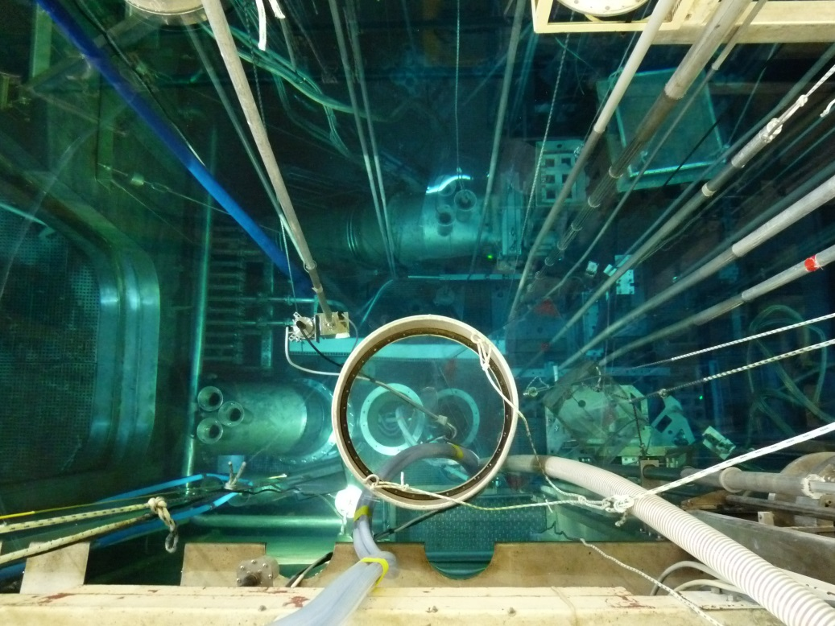
OSIRIS core
Natural convection valves
Masts: limits of working zone
Primary loop (hot leg)
Primary loop (cold leg)
Fig. 1. Working zone and natural convection valves in OSIRIS reactor pool

Physical boundaries of the working zone were materialised in OSIRIS pool by mean of a set of aquatic masts (see Fig. 1.). During the dives, someone was constantly responsible to prevent the diver from overcoming these limits and warn him with an aquatic mast.

3.2. Diving equipment and protection of diver against the risk of contamination
Diving Equipment required for this project consisted in dry diving suits. Air supply to divers was provided by the compressed air network of OSIRIS and monitored from the surface. Divers were linked to the air supply system by means of an air pipe. Air cylinders were only present for safety: 2 on the surface and 1 on the back of divers. The temperature of the water being around 28°C, cooling jackets were provided. They were used or not by each diver, depending on its wishes.

Each diver was also equipped by a video camera, a microphone and audio headset to remain in permanent communication with the surface. During the dives, video was continuously displayed on screen and could be recorded on request. An audio connection allowed the communication between the diver and specialists located above the surface, in the hall of the reactor.

Operating modes against the risk of contamination were strictly defined (See Fig. 2.).
- Divers wear high-density polyethylene suits (Tyvek™), gloves and overboots under their dry diving suit.
- Their diving equipment was cleaned and partly dried by an assistant during their emersion.
- People in contact with divers, in charge of their decontamination or to help for undressing also had adequate protection suits (Tyvek™)…

3.3. Equipment and worksite organization (Fig. 3.)
Temporary vestibules were settled to dress and undress the divers. This temporary installation included:
- an entrance/exit vestibule,
- a dressing/undressing vestibule,
- a decontamination vestibule (adjacent to the reactor pool),

Following equipment, useful for decontamination or possibly contaminated remained in the vestibule:
- diving equipment for two divers (one was used, a second for safety),
- protection against contamination (high-density polyethylene suits, masks, gloves and overboots…) ,
- decontamination items.

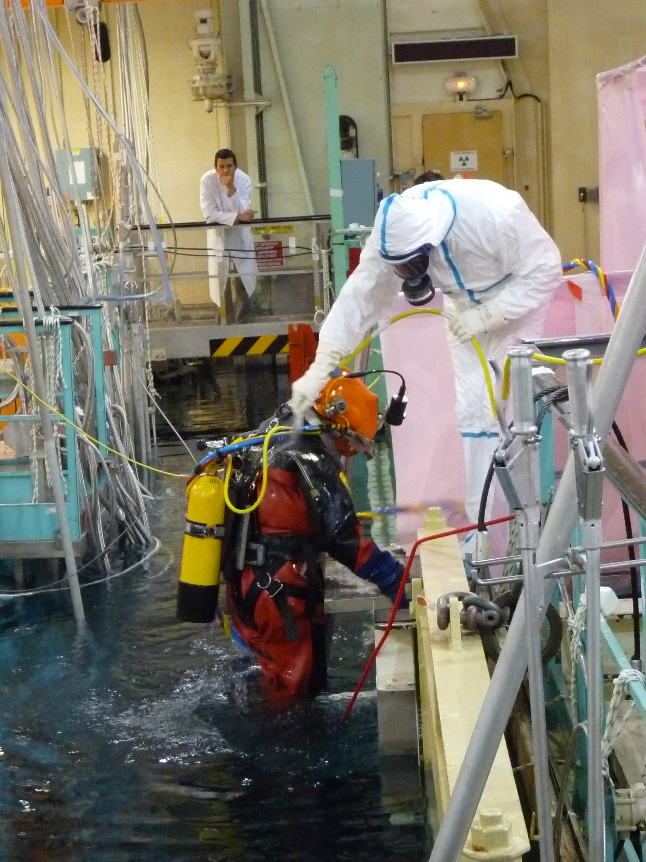
Fig. 2. Decontamination of a diver emerging from the reactor pool

An integrated working zone was created close to vestibules. This space gathered desks with the equipment of communication with divers, screens for online interpretation of the results, screens, monitoring of the air supply etc…

A full size stainless steel mock-up of the circuit to control had been realized prior to the intervention. During the whole intervention period, this mock-up was installed in the hall of OSIRIS, close to the integrated work zone and intensively used for briefings, trainings and resolution of practical difficulties.

A view of this worksite is given in Fig. 3.

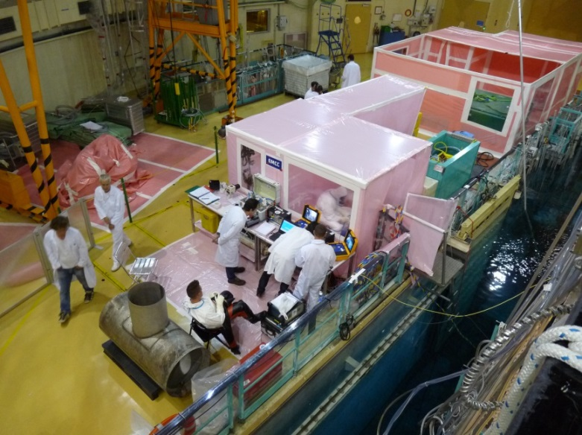
Fig. 3. Overview of worksite

4. Preparatory dive and video inspection
The first dive permitted to place “numbered bands” on the portions of circuit to inspect. These neoprene bands included lead numbers, used as marks for the localisation on the welds. Lead is visible under gamma radiography which facilitates the localisation on the radiographies welds. A good positioning of these bands was of very high practical importance.

After the bands were placed on the circuits, visual inspections were done. Divers used a hand video camcorder and a light projector. A life transmission was available and the whole sequence was also recorded. Lead marks located of the band allowed the localisation of the images of inspected zone.

5. Eddy current control
5.1. General Points
Eddy current inspection is based on the principle of electromagnetic induction. A probe, including a drive coil carrying alternative currents generates a primary magnetic field that induces eddy currents within the tested specimen. These eddy currents are modified when a defect is present.

5.2. Preparation work
The calibration of the probes was done on pre-established defects, included in a stainless steel mock-up of the section of pipes to control (Fig. 4).

Before the inspection, divers were also trained to practice eddy current controls on this stainless steel mock-up. The importance of the handling of the probe was the key point of the training of the divers (See Fig. 5.).

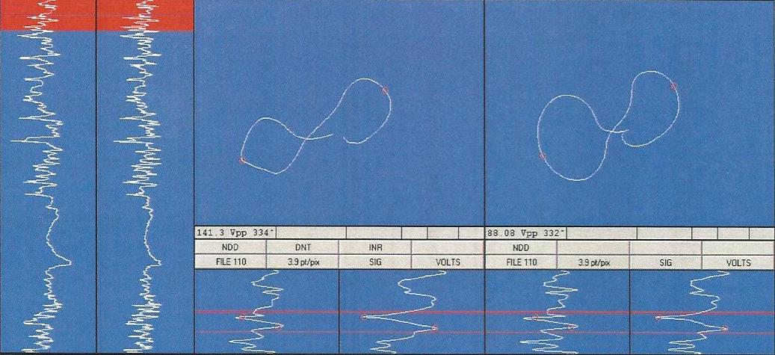
Fig 4. Image of a reference defect of the mock-Up identified by eddy Current

5.3. Realisation of the controls in the pool of OSIRIS
The 11th and 12th of September 2013, the numbered bands having been installed, eddy current controls could start. The presence of a video camcorder on the head of the divers was used as a video assistance to follow the displacement of the probe from the surface and to identify which portions of welds was being inspected.

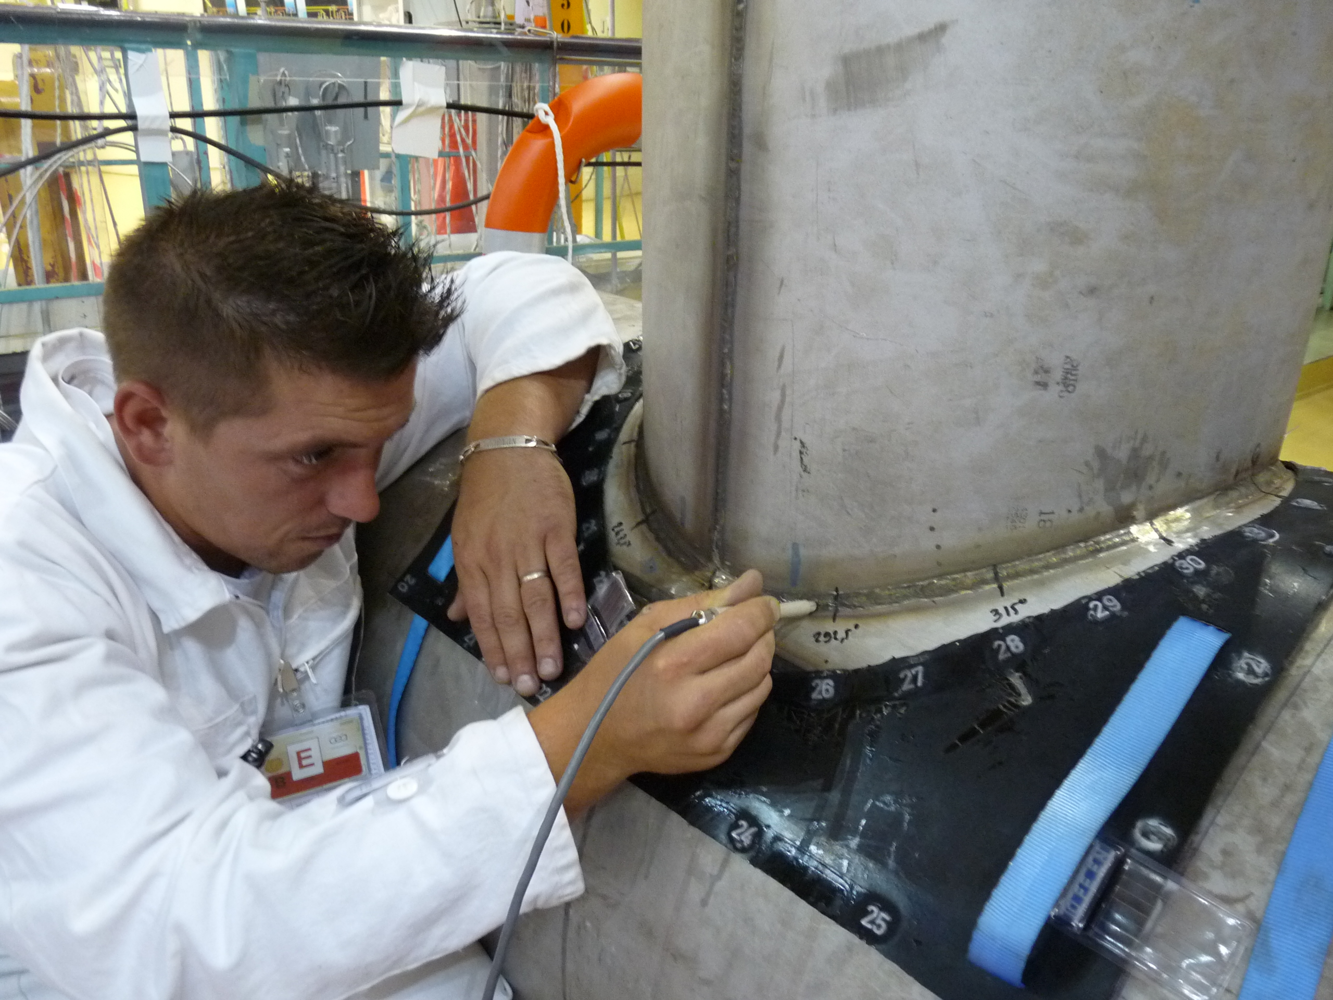
Fig. 5. Training to eddy current controls on the stainless steel mock-up

The conclusion of this inspection was the absence of any defect endangering the health of the inspected components.

6. Gamma radiography
The realisation of the gamma radiography was certainly the most delicate inspection realised during this outage.

6.1. General points
Gamma radiography consists in the realisation of pictures of objects by using the ability of gamma rays to penetrate various materials. The observed object is placed between a radioactive gamma source and a radio film. In case of underwater gamma radiography, the presence of water could have a negative impact on the quality of the image because of its interactions with gamma rays. This is why a 340 litres balloon, fitted to the geometry of the primary circuit was designed in order to permit the introduction of the source close to the welds without any attenuation or perturbation due to a water screen.

Fig. 6. Balloon used for gamma radiography

6.2. Installation and positioning of the balloon
Prior to the intervention, a procedure had been established to define how to proceed to correctly install the balloon in the primary circuit (See Fig. 6). Preparatory work was realised in a swimming pool where operating modes were tested and practical difficulties solved.

The operating mode to install the balloon in the primary circuit was the following:
- The diver introduces an empty balloon in the primary circuit of the reactor at the level of the branched pipe of the valve.
- The balloon is filled with demineralised water. During this phase the position of the balloon can be adjusted by the diver if necessary.
- Once the balloon is totally filled, the correct position is controlled by a video camera introduced in the primary circuit by the branch of the pipe of the adjacent valve. The correct position is obtained if the yellow circles painted on each extremity of the balloon are at the centre of the primary loop (see Fig. 6.).
- If a correct position is observed, water is substituted by air. If not, the balloon is emptied and the positioning process needs to be realised again.

This procedure gave good results during the intervention on the reactors even if some punctual difficulties may be reported (See §4.6)

6.3. Installation of films and radio films exposure
The balloon being correctly installed and the numbered band being in position, the radiographies of the welds could start.

A first dive was necessary to install a set of radio films along the weld to control before proceeding to each exposure. This positioning of the film was done by the diver and verified from the surface thanks to a video camera on the head of the diver. During this work, instructions could be given to the diver thanks to the audio connection with the surface.

It must be pointed that a single radio film cannot cover an entire weld. That is why two radiographic exposures done with two sets of films placed in two different positions are necessary, each set covering more than half of the length of the weld to control (See Fig. 7).

1
3
5
7
9
11
13
15
16
2
4
6
8
10
12
24
1
3
5
7
9
11
13
15
16
2
4
6
8
10
12
24
Fig. 7. Complete radiography of a circular weld realised in two steps

Once the films positioned, their exposure was realised by the introduction of an iridium source (¹⁹²Ir) in the irradiation nozzle. A distant hand-operated winch was used by an operator to push the source from a shielded “projector” along a 12 meters guide tube until an irradiation nozzle, located at the end of the guide tube (See fig. 5).

As a portion of the guide tube was located above the water in the hall of OSIRIS reactor, the evacuation of the hall was required during the introduction and the withdrawal of the source. The operator of the winch was the only person allowed to remain in the hall, at a place where he was protected from the radiations. By convenience, it was decided to forbid the access to the reactor hall during the whole radiography process, as long as the source was not positioned and locked back in its shielded “projector”.

After each film exposure, another dive was also necessary to collect the films.

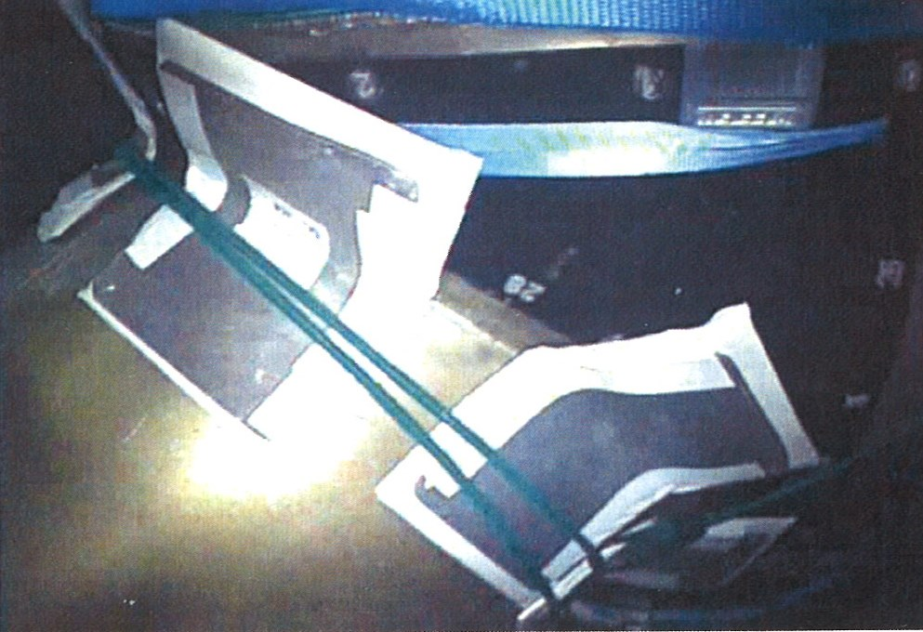
Fig. 9. Radiographic films positioned underwater around a circular weld

6.4. Quality of the pictures
The duration of a film exposure was chosen from 8 to 35 minutes depending on the weld inspected, its distance to the source (250 mm to 520 mm), the thickness of the weld and the optimisation of the parameters of the film development.

Radiographic films were developed on site. The results of previous exposures were exploited to adjust the parameters used for the next radiography or to decide to realise an additional radiography (See § 6.4).

6.4 Difficulties to get a correct position of the balloon and films
Eight gamma exposures should have been sufficient for the entire inspection (2 expositions per weld x 4 four welds). However, seven additional exposures were necessary. The reasons were the following:
- an inadequate position of the radiographic films,
- an inadequate position of the irradiation source (Cf. paragraph 6.3).

An improvement of the fastening of the films and a constant attention of diver for the positioning of the films permitted to solve the first point.

For the second point, it was discovered that the inadequate position of the iridium source was due to a bad positioning of the side of the balloon that could not be controlled by video camera (There is only one adjacent valve to introduce a camera in the primary circuit. Only the position of one side of the balloon can be controlled). An intervention to carefully reinstall the balloon was the solution for this second point.

In addition, optimisations of the time of exposure and of the parameters used for the development of the film permitted to increase the density of the picture and made the quality of picture less dependent on a very precise position of the source.

7. Result of the inspection
7.1. Results in terms of planning
Thanks to the important preparation work realised before the interventions on the reactor, only few technical hazards have been encountered and efficient solutions have been rapidly found.

The increase of the number of dives because of the difficulties for positioning the balloons and films was limited by an optimisation of the dives:
- Divers have put a set of film in position when the balloon was being filled by water instead of waiting,
- Divers have left the pool when the balloon was being filled by air instead of remaining underwater until the end of this operation.
- After film exposure, a single dive has most of the time been sufficient to remove the exposed films and also to install new ones in a single dive, instead of two as foreseen.

With these optimisations, the number of dives and the total duration of the inspection program were:
- 25 dives instead of 19 as initially foreseen,
- 19 hours and 30 minutes in immersion instead of 13 hours as foreseen.
The increase had no impact on the duration of the intervention.

7.2. Result in terms of irradiation and contamination
The collective irradiation dose was also extremely low:
- 0,062 mSv: collective dose for the divers (instead of 0,458 mSv foreseen),
- 0,171 mSv: total collective dose for the entire project.

This good result was the consequence of following raisons:
- Divers had worked around the must irradiative points. The water of the reactor pool had played an efficient role of protection against radiation.
- Constant efforts were made to remove irradiative items from zone used by divers in OSIRIS reactor pool.
- The radiation ambiance had decayed with time (The inspections took place at the end of the summer outage and initial cartographies had been done earlier during the outage).

In addition, the decontamination procedures for dressing/undressing the divers were efficient and well respected. No case of human contamination of divers or their co-workers was reported.

8. Conclusion
25 dives representing 19 hours underwater were necessary to fulfil the inspection program of the welds of connected pipes of the convection valves of OSIRIS.

This inspection who involved the competences and expertise of four companies was the result of almost one year of preparation. The scheduled duration of 3 weeks for the inspection was respected and the difficulties encountered were solved efficiently without impact on the planning of the outage.

The results of these inspections were satisfactory in terms of quality and positive in terms of health of the welds. The final report came to the conclusion that there was no damageable defect on the inspected welds and no evolution of cracks due to fatigue.

These positive results were a reward for the workers of OSIRIS reactor who have led this project and for all the participants of project who have contributed to the success of this operation.

